Spanish Fiesta with Portugal
10 Nights 11 Days
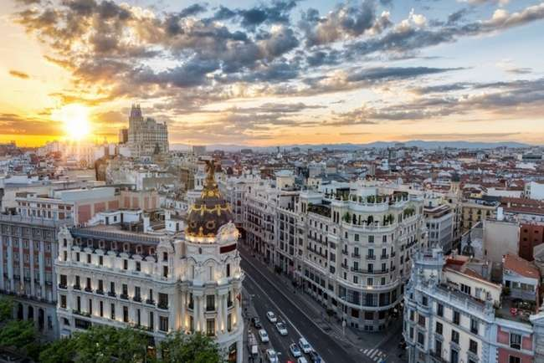
Madrid City

Factors
- Value-for-Money holiday which you will cherish for a lifetime.
- Visit 2 countries in 11 days: Spain and Portugal.
- All Important attractions and sightseeing included with some new additions. Visit Bullring, See the renowned Toledo sword factory, Visit Sintra and Cabo da Roca, Experience the renowned Flamenco Show, Mezquita-Catedral de Córdoba, Entrance to Alhambra Palace and Generalife Gardens, Valencia Cathedral, Excursion to Montserrat,
- Guided Tour in Madrid, Toledo, Salamanca, Porto, Lisbon, Granada, Valenciaand Barcelona.
- Services of a Professional & Knowledgeable Tour Manager accompanying you throughout the tour.
- Accommodation in superior 4-star hotels.
- Daily Continental buffet breakfast.
- Delicious unlimited meals with variety of Jain, Veg and Nonveg cuisine (Indian / Local) included as per itinerary.
- Daily mineral water bottle (500ml) per person
- Driver tips included

Day 1: Arrival in Madrid
Welcome to Madrid, Spain’s vibrant capital known for its rich history, iconic landmarks like the Royal Palace, and world-class museums such as the Prado. This lively city combines stunning architecture with a warm, bustling atmosphere.Upon arrival at Madrid–Barajas Adolfo Suárez Airport, your group will be greeted by a professional tour manager who will escort you to your hotel and assist with check-in.Take some leisure time to relax or explore the surroundings. In the evening, proceed for dinner
Overnight in Madrid (Dinner)

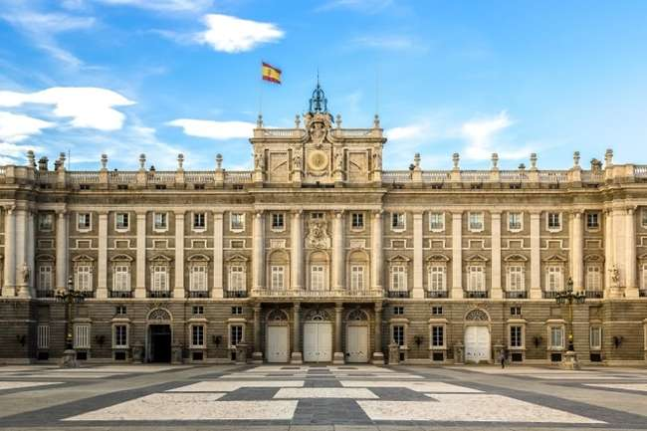
Day 2: Guided city tour of Madrid. Visit Bullring. Guided tour of Toledo. See the renowned Toledo sword factory.
Start your day with a hearty breakfast at the hotel. Next, embark on a guided tour of Madrid, where you will explore its historic and cultural highlights, including a visit to the renowned Bullring, an iconic symbol of Spanish tradition.
Later, visit a traditional sword factory, learning about the craftsmanship behind Spain’s famed blades. Following this, enjoy a guided tour of Toledo, a UNESCO World Heritage city known for its medieval architecture, diverse cultural heritage, and stunning landscapes.
Royal Palace Madrid
Return to Madrid in the evening and unwind at your hotel for an overnight stay.
Overnight in Madrid (Breakfast, Lunch, Dinner)

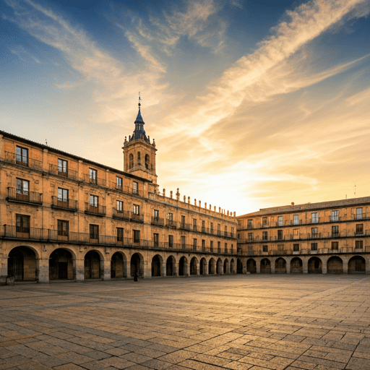
Day 3: Madrid to Porto via Salamanca
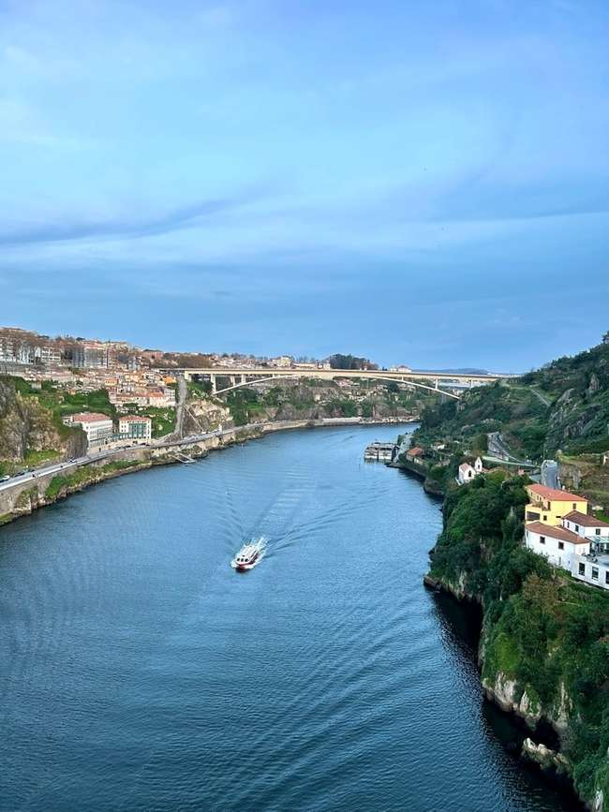
Begin your day with breakfast at the hotel before checking out. Depart for Salamanca, a historic city celebrated for its golden sandstone buildings and vibrant university life. Upon arrival, meet your English-speaking guide and enjoy a guided tour of Salamanca’s key landmarks. Highlights include the magnificent Plaza Mayor, one of the most beautiful squares in Spain, and the University of Salamanca, established in 1218 and renowned as one of Europe’s oldest educational institutions. Marvel at the intricate carvings on the university facade and the Casa de las Conchas, adorned with shell motifs symbolizing the Order of Santiago.
Plaza Mayor
After exploring Salamanca, continue your journey to Porto, Portugal. Upon arrival, check into your hotel and relax.
Overnight in Porto (Breakfast, Lunch, Dinner)

Day 4: Drive to Porto. Guided tour of Porto.
Post breakfast, check out from your hotel and proceed to Porto, a beautiful coastal city known for its rich history, stunning landscapes, and vibrant culture. Porto is famous for its iconic Douro River views, historic architecture, and being the heart of Portugal’s famous Port wine production.
Upon arrival, embark on a guided tour of Porto, where you’ll explore significant landmarks such as the Dom Luís I Bridge, offering panoramic views of the river, the Ribeira district with its colorful streets, and the renowned Port wine cellars. Your guide will share insights into Porto’s history, culture, and local traditions.
After completing the tour, drive towards Lisbon on a scenic journey Relax during the drive and enjoy the picturesque landscapes of Portugal along the way.
Douro River
Overnight in Lisbon (Breakfast, Lunch, Dinner)
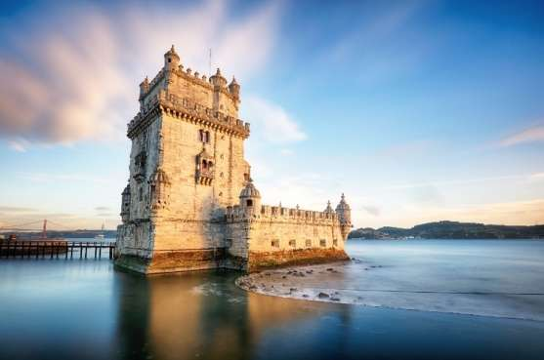
Belem Tower

Day 5: Guided tour of Lisbon. Visit Sintra and Cabo da Roca
Start your day with a guided tour of Lisbon, where you’ll visit iconic landmarks like the Belém Tower, Jerónimos Monastery, and the scenic Alfama district. Then, head to Sintra, a charming town known for its stunning landscapes and historical significance. Here, explore the magnificent Pena Palace, a colorful fairytale-like attraction. Next, visit Cabo da Roca, the westernmost point of continental Europe, offering breathtaking views of the Atlantic Ocean. Later return to your hotel.
Overnight in Lisbon (Breakfast, Lunch, Dinner)

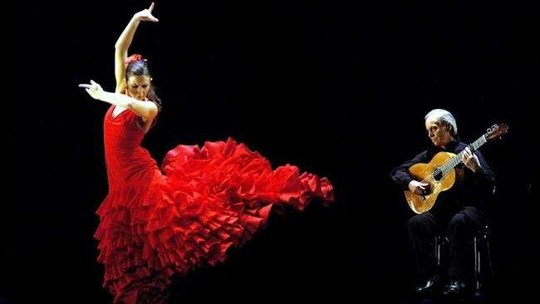
Day 6: Orientation tour of Seville. Experience the renowned Flamenco Show.
Post breakfast, check out from your hotel and drive to Seville. Upon arrival, enjoy a a quick orientation city tour, visiting landmarks like the majestic Seville Cathedral, the stunning Alcázar of Seville, and the charming Santa Cruz district. Later enjoy an authentic Flamenco show, a celebration of Spanish culture and passion. Flamenco is a traditional Andalusian art form, known for its intense and expressive dance, powerful guitar rhythms, and soulful singing.
Flamenco Show
Overnight in Seville (Breakfast, Lunch, Dinner)
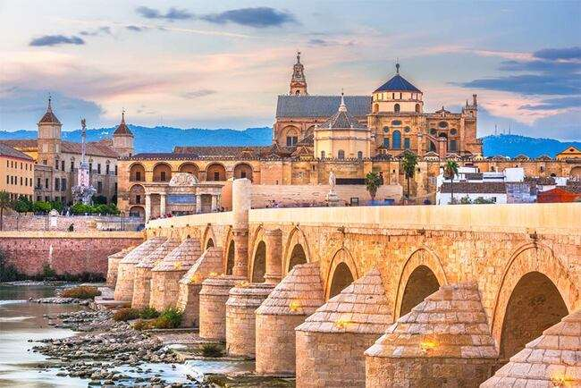
Day 7: Onto Granada. Enroute, visit Cordoba with a local guide. See the Mezquita Cathedral.
After breakfast, check out from your hotel and drive to Córdoba, a city renowned for its rich history and stunning architecture. Here, enjoy a guided tour highlighting the famous Mezquita-Catedral de Córdoba, a magnificent example of Islamic and Christian architectural fusion. Marvel at its intricate arches, mosaics, and impressive interior. After your tour, continue your journey to Granada. Check in to your hotel in Granada
Roman Bridge
Overnight in Granada (Breakfast, Lunch, Dinner)

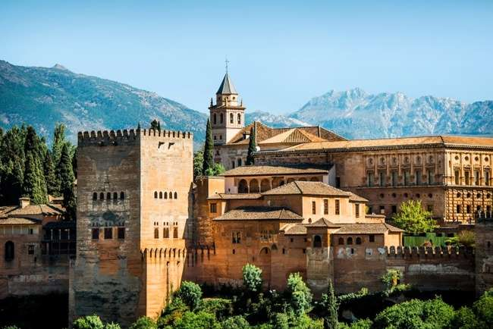
Day 8: Guided tour of Granada. Entrance to Alhambra Palace and Generalife Gardens.
Alhambra Palace
Today, checkout from your hotel and proceed for a guided tour of Granada, including a visit to the iconic Alhambra Complex, a UNESCO World Heritage Site famous for its Nasrid Palaces, Moorish designs, and panoramic views of the city. Then, explore the beautiful Generalife Gardens, known for their lush greenery, serene atmosphere, and stunning landscapes. After the tour, drive to Valencia, a vibrant coastal city blending rich history with modern innovation. Known for its futuristic City of Arts and Sciences, golden beaches, and the charm of its old town, Valencia offers a perfect mix of culture, gastronomy, and Mediterranean beauty. Check in to your hotel.
Overnight in Alicante / Valencia (Breakfast, Lunch, Dinner)

Day 9: Guided tour of Valencia. Drive to Barcelona.
After breakfast, start your day with a guided tour of Valencia, visiting the futuristic City of Arts and Sciences, a stunning complex with unique architecture and attractions like an aquarium and science museum. Next, explore the Valencia Cathedral, showcasing a mix of Romanesque, Moorish, and Gothic styles. Wander through the Old Town, experiencing local markets, charming streets, and traditional Spanish culture. Later much awaited city of Barcelona. The vibrant capital of Catalonia in northeastern Spain, is a city that seamlessly blends rich history, modern design, and a captivating cultural scene. Its iconic architecture, notably the mesmerizing works of Antoni Gaudí such as the Sagrada Família and Park Güell, defines the city's skyline.
Overnight in Barcelona (Breakfast, Lunch, Dinner)

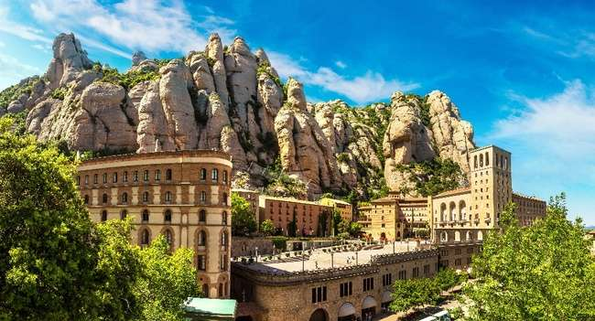
Day 10: Guided city tour of Barcelona. Excursion to Montserrat.
Montserrat

Today, proceed for a Guided tour of Barcelona. Enjoy a guided walking tour of Barcelona's Gothic Quarter, with a professional English speaking guide to accompany you. Wander past important historic monuments such as the Saló del Tinell, the Capella de Santa Àgata and the Palau del Lloctinent. Visit the Olympic Village, Columbus monument and Montjuïc Mountain where you will be able to see the Olympic Stadium, see Plaza de Cataluna, lively Ramblas the most famous street of Barcelona. See the Sagrada Familia. The Sagrada Família is a large unfinished Roman Catholic minor basilica and is a one-of-a-kind temple, for its origins, foundation and purpose. Five generations now have watched the Temple progress in Barcelona. Today, more than 135 years after the laying of the cornerstone, construction continues on the Basilica. Next we to one of the most popular day trip from Barcelona – Montserrat. It a visit to a unique mountain range offering views over Catalonia. Venture into the Catalan countryside to visit Montserrat on this full-day tour from Barcelona. See the Basilica and Monastery on Montserrat, a beautiful, multi-peak mountain with dramatic rock formations, with free time to continue exploring the museum, farmer's market, or views from the ridge of Cavall Bernat.
Overnight in Barcelona (Breakfast, Lunch, Dinner)

Day 11: Fly back home
Your memorable holiday ends, today it’s time to fly back home. Say goodbye to the wonderful new friends you have made on the tour. Check out and depart for the Airport with pleasant memories of your European trip which you will cherish for a lifetime. (Breakfast)

Inclusion: Sightseeing and excursions

SPAIN
Madrid
- Guided City Tour of Madrid
- Visit Bullring
Toledo
- Guided City tour of Toledo
- See Toledo sword factory

Salamanca
- Guide Tour of Salamanca

PORTUGAL
Porto
- Guided City tour of Porto

Lisbon
- Guided City tour of Lisbon
- Visit Sintra and Cabo da Roca

SPAIN
Seville
- Orientation City Tour of Seville
- Enjoy the Flamenco Show

Cordoba
- Guided Tour of Cordoba
- Mezquita-Catedral de Córdoba

Granada
- Guided City tour of Granada
- Entrance to Alhambra Palace and Generalife Gardens

Valencia
- Guided City tour of Valencia

Barcelona
- Guided City Tour of Barcelona
- See The Sagrada Familia
- Excursion to Montserrat

Accommodation:
- 02 nights accommodation in B&B Madrid or similar hotel in Madrid
- 01 night accommodation in TRYP Expo or similar hotel in Porto
- 02 nights accommodation in Melia or similar hotel in Lisbon
- 01 night accommodation in Vertice Sevilla or similar in Seville
- 01 night accommodation in Abades Nevada or similar Granada
- 01 night accommodation in Mas Camarena or similar in Valencia
- 02 nights accommodation in HtopPlatja Park or similar in Barcelona

Meals As per itinerary:
- Daily Continental Buffet Breakfast.
- 09 Indian Jain/Vegetarian/Non-Vegetarian Lunches.
- 10 Indian Jain/Vegetarian/Non-Vegetarian Dinners.
- Daily Mineral Water Bottle (500ml)

Driver Tips:
- Tips to coach drivers per person, per day 5 EURO will be charge and added in the final payments a for the duration of the tour.

Payment Policy:
100, 000.00 INR per person at the time of the booking
IF we booked your air tickets, Full payment of the cost within 1 week of the ticket booking
75 days prior to tour departure 75000.00 INR per person prior to
60 Days prior to tour departure full paymentwith tips 5 euro per person per dayshould be
paid and cleared from our bank.

Cancellation Policy:
100, 000.00 INR per person at the time of the booking
IF we booked your air tickets, Full payment of the cost within 1 week of the ticket booking
75 days prior to tour departure 75000.00 INR per person prior to
60 Days prior to tour departure full payment should be paid and cleared from our bank.
IF two travelers sharing room in tour and one of them drop out/ cancelled the tour,
remaining traveler charge as a single traveler.

Important Notes:
GST 5%is applicable on total cost
TCS -5to 20% on total tour cost as per Indian govt, rules
Exchange rate for Euro= 96 INR will be charge at rate of the final payment time.
All Hotel Room category is standard room (Basic category) Hotel is not
In city centre or downtown.
We are not giving refund of any sightseeing closed due to maintenance
Or weather, political, riots and /or other situations not under our control.

Vehicle Policy:
During Sight Seeing Driver Will Try His Best to Park as Much Closer He
Can, From There Guest Has to Make His Way by Walk or They Have To
make their own transfer If Requireany.In caseofcoachbreakdown
TRAVELGROCERYDMC.PVT.LTD and tour providerswilldoTheir
best effort to fix the problem as soon as possible. But make sure there
will be no refund for inconvenience cause. Request to all guest please
don’t leave Any Unattended Item in vehicle while leaving the vehicle.

What your tour price does not include:
- The cost of the Airfare, Passport, POE charges, Visa charges, Overseas Travel Insurance, etc.
- Any expenses of personal nature such as Porterage, Laundry, and Alcohol, Food or Drink not in the regular menus provided by us, mini bar and telephone calls
- Any extra meals not included in the itinerary. Meals are pre - set and a choice of menu is not available, No refund of any unused meals, services, sightseeing, etc.
- Cost of excursions, city sightseeing, entrance fees and local guides availed of by the passengers, other than that mentioned in ‘What your tour price includes’
- GST, TCS and other taxes as applicable
- Anything which is not specified in the Itinerary
- Any item and services not mentioned in Inclusions.
- Tips to coach drivers per person, per day 5 EURO will be charge and added in the final payments a for the duration of the tour.

Instruction for Arrival & Departure Coach Transfers:
Madrid (MAD Airport) Arrival Transfer: Flight landing time should be between 08 AM – 1300hrs.
Barcelona (BCN Airport) Departure Transfer: The coach will drop at BCN Airport by 1100 AM.

IMP Notes for Transfers:
- Please advise your client that there may be waiting up to 02 Hours (Post reaching in arrival hall) for arrival transfers.
- If flight timings are before /after the suggested timing, client has to arrange his private transfers on direct payment basis. We will not reimburse any cost for private transfers.

NOTES:
- A person below 12 years of age on the entire tour will be considered a child
- As a 3rd person in a triple room, most hotels use rollaway beds and room size may be the same as the double room
- Tours will operate subject to all Government regulations
- All Local taxes, entrances and services are calculated as on 1st October 2021, any increase in local taxes, entry tickets and other services has to be borne and paid by the traveller/agent.
- All transfers and extensive sightseeing with entrance fees (as specified in the itinerary) will be done in an air-conditioned coach
- On reaching Eiffel Tower, if there is a very long queue, we will be taking you to the Montparnasse tower.
- It is suggested to carry One check in bag and one hand bag per person only, due to limited boot space in the coach
- Services of our tour manager or local representatives, while on tour
- On some occasions, you may have to join another group in case your group does not have adequate members
- A local representative or your coach driver may only be there to assist you during your initial part of the tour
- Land surcharges applicable on certain departure dates which will be notified
- If certain sightseeing/excursions are closed, then alternate sight- seeing will be arranged.
- Kindly note that on certain departure dates the tour routing could change. In some tours, there is also a possibility that the tour could operate in reverse itinerary. However, you will not miss any sightseeing or excursions that are mentioned in the itinerary unless its closed due to a holiday. Your Tour Manager will notify you the same
- In case of inordinate delays and strict driving laws, packed dinner may be provided on that day
- Please check with your Sales representative for final details
- In case of any increase in any taxes in Europe, there would be a change in price which will be justified
- We reserve the right to claim from the passengers, any additional expenses incurred due to delay or changes in the schedule of trains, flights, coach, cruise or other services
- We reserve the right to change any itinerary for operational reasons and reasons beyond the control of us due to Force Majeure related to weather conditions, strike, etc. Force Majeure related to weather conditions, strike, etc.
- We shall not accept any liability or responsibility for any damages, loss, injury, accident, death, delay, breakdown or irregularity, which may occur during the tour, due to weather conditions, strikes, war, quarantine and or any other cause whatsoever and all such loss or expenses must be borne by the passenger
- Tours are operated subject to Reserve Bank of India / Government of India regulations
- Tour cost is payable in EURO out of your BTQ entitlement of the passengers

DirectJoiningGuestHavetoArrangeHotelTransferforCheckinandcheckout
dayby themselves. operation of a Group Tour Is a Subject to Minimum Participation of 25 Paying Adult Passenger. Any Increase in Visa Fee /Airfare / Fuel Price / Change in government Regulations Taxes Etcwill affect your tour Cost.
Tour itinerary will be Strictly Follow as Per Timing. In UnavoidableSituationour
tourmanagerCanMakeChangeswithThe ConcernofHead Office.TourManagerIsNotAuthorizetoMakeChangesinItinerary asPerGuestConvenience.InCaseof anyDeportationDuetoImmigrationand CustomClearance TRAVEL GROCERY DMC PVTLTDand tour providers will Not Be Responsible. There Will Be No Refund for Tour Package. OptionalSightseeing have tobePre-BookwithAnadditionalCost.
ThereIsNo Refundforany unutilizedServices.
ItineraryCostIsperpersononTwinSharingbasis.It IncludeonlythoseactivitiesWhicharelistedin theSame.
ItinerarycostdoesnotInclude anyPersonalNatureExpenses.Such as tips, Misc.Expenses,Laundry,Liquor,Porterage. Medical expenses, travel insurance Etc.Internationaltourguestmusthaveto reachAirportbefore3Hrs.OfdepartureTime.
ForNRI–PassengersStayinginIndiafor MoreThan180dayswillhavetotakePolice ClearanceCertificatefromCommissioner ofPoliceforWhichTRAVELGROCERYDMC.PVT.LTD and tour providerswillnotbeResponsible.
PassengersareRequestedtoSubmitXeroxCopyofPassport alongwithpageShowing arrivalstampinIndia.

