Jewels of East Europe
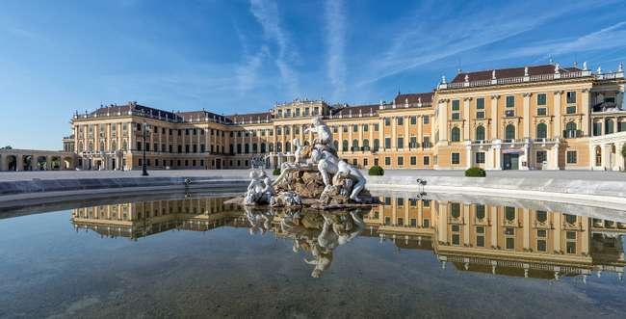
07 NIGHTS /08 DAYS
Schönbrunn Palace

HIGHLIGHTS
- Value-for-Money holiday which you will cherish for a lifetime
- Visit 5 countries in 08 days: Austria, Hungary, Slovakia, Czech Republic and Germany
- All Important attractions and sightseeing included with some new additions. Visit SchoenbrunnPalace, Cruise on Danube River, Orientation tour of Szentendre, Orientation tour of Bratislava, Visit to Prague Castle viewing Gallery and Daschstein Glacier.
- Guided tour in Vienna, Budapest & Salzburg.
- Services of a Professional & Knowledgeable Tour Manager accompanying you throughout theTour.
- Accommodation in superior 4-star hotels
- Daily Continental buffet breakfast.
- Delicious unlimited meals with variety of Jain, Veg and Nonveg cuisine (Indian / Local) included asper itinerary.
- Daily mineral water bottle (500ml) per person
- Driver tips included

Day 1
Arrive in Vienna
Welcome to Vienna, the capital of Austria, is a city renowned for its rich history, cultural heritage, and vibrant arts scene. Upon arrival at Vienna Airport, meet your Friendly representative who will later escort you to your hotel and check in. In the evening, enjoy a delightful dinner before returning to the hotel for an overnight stay.
Overnight stay at the hotel in Vienna. (Dinner)

Day 2
Vienna to Budapest
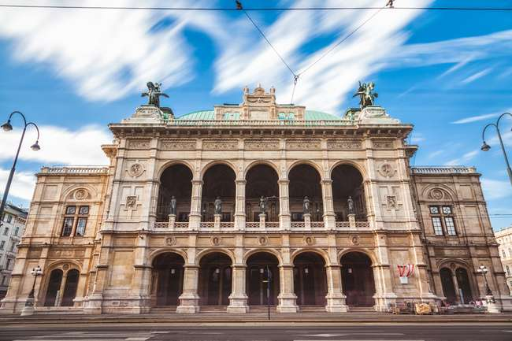
After breakfast, check out and proceed to Budapest before that proceed on a guided city tour, admire landmarks such as the Ringstrasse, the Vienna Opera House, and St. Stephen’s Cathedral. Visit the magnificent Schönbrunn Palace, once the summer residence of the Habsburgs. Relish an Indian lunch and enjoy free time Later proceed back to Budapest. After dinner at an Indian restaurant, check into your hotel for an overnight stay.
Vienna Opera House
Overnight stay at the hotel in Budapest (Breakfast, Lunch, Dinner)

Day 3
Discovering Budapest.
Begin your day with breakfast and a guided city tour of Budapest, exploring landmarks like Buda Castle, the Hungarian Parliament, and Heroes’ Square. After lunch at an Indian restaurant, experience a scenic Danube River cruise, offering stunning views of the city’s illuminated skyline. Later proceed to Szentendre, a charming riverside town in Hungary, is renowned for its picturesque streets, vibrant art scene, and Mediterranean atmosphere. Enjoy dinner at an Indian restaurant before returning to your hotel.
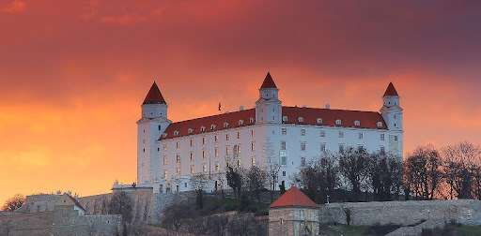
Overnight stay at the hotel in Budapest (Breakfast, Lunch, Dinner)
BratislavaCastle

Day 4
Budapest – Bratislava – Prague.
After breakfast, check out and travel to Bratislava, the quaint capital of Slovakia. Enjoy an orientation tour of the city's landmarks, including Bratislava Castle and the Old Town’s medieval streets. Following lunch at an Indian restaurant, Continue your journey to Prague, the enchanting capital of the Czech Republic. Upon arrival, savour a flavourful Indian dinner and unwind at your hotel.
Overnight stay at the hotel in Prague. (Breakfast, Lunch, Dinner)
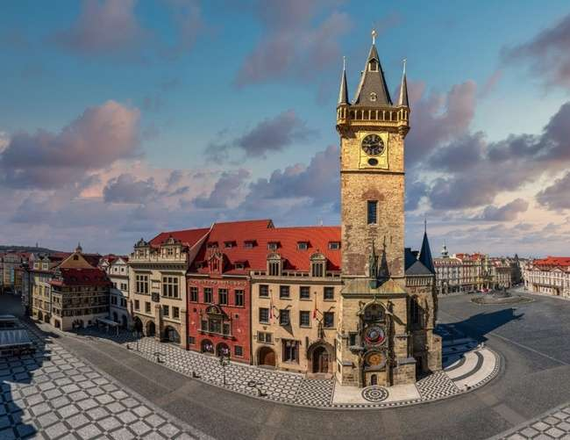
Astronomical Clock

Day 5
Discover Prague.
Start your day with breakfast and a guided city tour of Prague. Discover the majestic Prague Castle, Charles Bridge, and the Old Town Square with its famous Astronomical Clock. Visit the castle viewing gallery for panoramic city views. After an Indian lunch drive to kutna Hora, Kutná Hora is a historical town in the Czech Republic. Offering a fascinating glimpse into the medieval and Baroque eras. Later proceed back to Prague. Conclude the day with dinner at an Indian restaurant and an overnight stay in Prague.
Overnight stay at the hotel in Prague. (Breakfast, Lunch, Dinner)

Day 6
Prague – Salzburg
Begin your day with breakfast before heading to Salzburg, the city of Mozart. After a delicious lunch at an Indian restaurant, Proceed to Meet your professional English speaking guide who will provide a captivating exploration of this picturesque city known for its rich history and baroque architecture. Immerse in the birthplace of Mozart, discovering iconic landmarks like the Hohensalzburg Fortress and Mirabell Palace. The tour often weaves through charming streets, offering insights into Salzburg's cultural heritage, making it an engaging and informative experience for those seeking to uncover the city's enchanting secrets. Later savor a flavorful Indian dinner and unwind at your hotel.
Overnight stay at the hotel in Salzburg. (Breakfast, Lunch, Dinner)

Day 7
Salzburg – Hallstatt – Schladming – Munich.
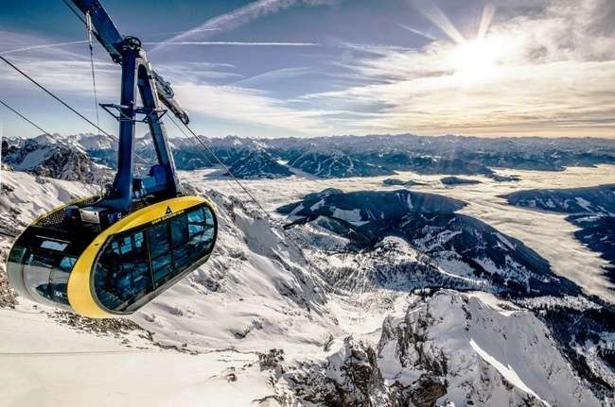
After breakfast, depart and drive to the picturesque village of Hallstatt, renowned for its scenic beauty and alpine charm. Stroll through its quaint streets or relax by the serene lake. Later proceed to Schladming, a charming alpine town. Experience the breathtaking Dachstein Glacier via a thrilling cable car ride. Enjoy lunch with stunning mountain views and explore attractions like the Ice Palace, the daring Stairway to Nothingness, and the Suspension Bridge. Later Drive to Munich, the vibrant capital of Bavaria! Upon arrival end your day with dinner at an Indian restaurant before checking into your hotel in Munich.
Dachstein Glacier Cable Car
Overnight stay at the hotel in Munich. (Breakfast, Lunch, Dinner)

Day 8
Fly back home
Your memorable holiday ends, today it’s time to fly back home. Say goodbye to the wonderful new friends you have made on the tour. Check out and depart for the Airport with pleasant memories of your European trip which you will cherish for a lifetime.
(Breakfast)

Inclusion: Sightseeing and excursions

AUSTRIA
Vienna
- Guided City tour of Vienna
- Visit to Schoenbrunn Palace

Salzburg
- Guided City tour of Salzburg

Hallstatt
- Cable Car to Daschstein Glacier
- Ice Palace, Stairway to Nothingness, Suspension bridge etc

HUNGARY
Budapest
- Guided City tour of Budapest
- Cruise on River Danube

Szentendre
- Orientation tour of Szentendre

SLOVAKIA
Bratislava
- Orientation Tour of Bratislava

CZECH REPUBLIC
Prague
- Guided City tour of Prague
- Visit to Prague Castle viewing Gallery
- Kutna Hora

Accommodation:
- 01 night Event Hotel Pyramid / Austria Trend or similar in Vienna
- 02 nights Hotel Danubius Arena / Hungaria or similar in Budapest
- 02 nights Hotel NH / Panaroma Hotel or similar in Prague
- 01 night accommodation in a 4 star hotel in Salzburg
- 01 night Hotel Mercure / Dormero or similar in Munich

Meals
- Daily Continental Buffet Breakfast.
- 06 Indian Jain/Vegetarian/Non-Vegetarian Lunches.
- 07 Indian Jain/Vegetarian/Non-Vegetarian Dinners.
Daily Mineral Water Bottle (500ml)

Driver Tips:
- Tips to coach drivers per person, per day 5 EURO will be charge and added in the final payments a for the duration of the tour.

For Complimentary Transfers the Instruction are mentioned below.
Instruction for Arrival & Departure Transfers
Jewels of East Europe (07 Nights & 08 Days)
Vienna (VIE Airport) Arrival Transfer – Flight landing time should be between 08 AM – 1300 HRS. Transfer will be at 16:00 hrs
Munich (MUC Airport) Departure Transfer: The coach will drop at MUC Airport by 1100 AM. Please book your flight accordingly.

Payment Policy:
100, 000.00 INR per person at the time of the booking
IF we booked your air tickets, Full payment of the cost within 1 week of the ticket booking
75 days prior to tour departure 75000.00 INR per person.
60 Days prior to tour departure full payment with tips 5 euro per person per dayshould be
paid and cleared from our bank.
IF two travelers sharing room in tour and one of them drop out/ cancelled the tour,
remaining traveler charge as a single traveler.

Cancellation Policy with full airfare cost:
90 days prior to tour departure 40,000.00 INR per person at the time of cancellation
IF we booked your air tickets, Full payment.
75 days prior to tour departure 150000.00INR per person.
60 – 44 Days prior to tour departure full payment.

Important Notes:
GST 5%is applicable on total cost
TCS -5to 20% on total tour cost as per Indian govt, rules
Exchange rate for Euro= 96 INR will be charge at rate of the final payment time.
All Hotel Room category is standard room (Basic category) Hotel is not
In city centre or downtown.
We are not giving refund of any sightseeing closed due to maintenance
or weather, political, riots and /or other situations not under our control.

Vehicle Policy:
During Sight Seeing driver will try his best to park as much closer He
can, from there guest has to make his way by walk or they have To
make their own transfer If require any.In caseofcoachbreakdown
TRAVELGROCERYDMC.PVT.LTD and tour providerswilldoTheir
best effort to fix the problem as soon as possible. But make sure there
will be no refund for inconvenience cause. Request to all guest please
don’t leave Any Unattended Item in vehicle while leaving the vehicle.

What your tour price does not include:
- The cost of the Airfare, Passport, POE charges, Visa charges, Overseas Travel Insurance, etc.
- Any expenses of personal nature such as Porterage, Laundry, and Alcohol, Food or Drink not in the regular menus provided by us, mini bar and telephone calls
- Any extra meals not included in the itinerary. Meals are pre - set and a choice of menu is not available, No refund of any unused meals, services, sightseeing, etc.
- Cost of excursions, city sightseeing, entrance fees and local guides availed of by the passengers, other than that mentioned in ‘What your tour price includes’
- GST, TCS and other taxes as applicable
- Anything which is not specified in the Itinerary
- Any item and services not mentioned in Inclusions.
- Tips to coach drivers per person, per day 5 EURO will be charge and added in the final payments a for the duration of the tour.

IMP Notes for Transfers:
- Please advise your client that there may be waiting up to 02 Hours (Post reaching in arrival hall) for arrival transfers.
- If flight timings are before /after the suggested timing, client has to arrange his private transfers on direct payment basis. We will not reimburse any cost for private transfers.

NOTES:
- A person below 12 years of age on the entire tour will be considered a child
- As a 3rd person in a triple room, most hotels use rollaway beds and room size may be the same as the double room
- Tours will operate subject to all Government regulations
- All Local taxes, entrances and services are calculated as on 1st October 2021, any increase in local taxes, entry tickets and other services has to be borne and paid by the traveller/agent.
- All transfers and extensive sightseeing with entrance fees (as specified in the itinerary) will be done in an air-conditioned coach
- On reaching Eiffel Tower, if there is a very long queue, we will be taking you to the Montparnasse tower.
- It is suggested to carry One check in bag and one hand bag per person only, due to limited boot space in the coach
- Services of our tour manager or local representatives, while on tour
- On some occasions, you may have to join another group in case your group does not have adequate members
- A local representative or your coach driver may only be there to assist you during your initial part of the tour
- Land surcharges applicable on certain departure dates which will be notified
- If certain sightseeing/excursions are closed, then alternate sight- seeing will be arranged.
- Kindly note that on certain departure dates the tour routing could change. In some tours, there is also a possibility that the tour could operate in reverse itinerary. However, you will not miss any sightseeing or excursions that are mentioned in the itinerary unless its closed due to a holiday. Your Tour Manager will notify you the same
- In case of inordinate delays and strict driving laws, packed dinner may be provided on that day
- Please check with your Sales representative for final details
- In case of any increase in any taxes in Europe, there would be a change in price which will be justified
- We reserve the right to claim from the passengers, any additional expenses incurred due to delay or changes in the schedule of trains, flights, coach, cruise or other services
- We reserve the right to change any itinerary for operational reasons and reasons beyond the control of us due to Force Majeure related to weather conditions, strike, etc. Force Majeure related to weather conditions, strike, etc.
- We shall not accept any liability or responsibility for any damages, loss, injury, accident, death, delay, breakdown or irregularity, which may occur during the tour, due to weather conditions, strikes, war, quarantine and or any other cause whatsoever and all such loss or expenses must be borne by the passenger
- Tours are operated subject to Reserve Bank of India / Government of India regulations
- Tour cost is payable in EURO out of your BTQ entitlement of the passengers

DirectJoiningGuestHavetoArrangeHotelTransferforCheckinandcheckout
dayby themselves. operation of a Group Tour Is a Subject to Minimum Participation of 25 Paying Adult Passenger. Any Increase in Visa Fee /Airfare / Fuel Price / Change in government Regulations Taxes Etcwill affect your tour Cost.
Tour itinerary will be Strictly Follow as Per Timing. In UnavoidableSituationour
tourmanagerCanMakeChangeswithThe ConcernofHead Office.TourManagerIsNotAuthorizetoMakeChangesinItinerary asPerGuestConvenience.InCaseof anyDeportationDuetoImmigrationand CustomClearance TRAVEL GROCERY DMC PVTLTD and tour providers will Not Be Responsible. There Will Be No Refund for Tour Package. Optional Sightseeing have tobePre-BookwithAn additionalCost.
ThereIsNo Refundforany unutilizedServices.
ItineraryCostIsperpersononTwinSharingbasis.It IncludeonlythoseactivitiesWhicharelistedin theSame.
ItinerarycostdoesnotInclude anyPersonalNatureExpenses.Such as tips, Misc.Expenses,Laundry,Liquor,Porterage. Medical expenses, travel insurance Etc.Internationaltourguestmusthaveto reachAirportbefore3Hrs.OfdepartureTime.
ForNRI–PassengersStayinginIndiafor MoreThan180dayswillhavetotakePolice ClearanceCertificatefromCommissioner ofPoliceforWhichTRAVELGROCERYDMC.PVT.LTD and tour providerswillnotbeResponsible.
PassengersareRequestedtoSubmitXeroxCopyofPassport alongwithpageShowing arrivalstampinIndia.

