Scandinavia Delights
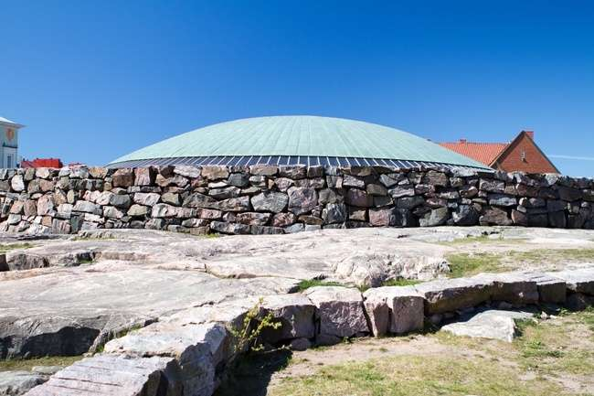
09 Nights / 10 Days
Rock Church

Factors
- Value-for-Money holiday which you will cherish for a lifetime.
- Visit 4 countries and 2 overnight cruises in 10 days: Finland, Sweden, Norway and Denmark.
- All Important attractions and sightseeing included with some new additions. Visit Rock Church, Visit the Sibelius Monument, Entrance to Drottningholm Palace, visit to the maritime museum – Vasa Museum, fascinating ride in the gondola up to SkyView of Stockholm, Museum of Cultural History, Vigeland sculpture Park, visit to the top of Holmenkollen Ski Jump, Norway in Nutshell, Visit the Mt. Floyen by funicular, Visit the H.C. Andersen Museum, Nyhaven cruise, Visit Carlsberg brewery with Beer tasting and Entrance to Tivoli Garden.
- Guided Tour in Helsinki, Stockholm, Oslo, Bergen and Copenhagen.
- Overnight Cruise to Stockholm and Copenhagen.
- Services of a Professional & Knowledgeable Tour Manager accompanying you throughout the tour.
- Accommodation in superior 4-star hotels.
- Daily Continental buffet breakfast.
- Delicious unlimited meals with variety of Jain, Veg and Nonveg cuisine (Indian / Local) included as per itinerary.
- Daily mineral water bottle (500ml) per person
- Tips to coach drivers per person, per day 5 EURO will be charge and added in the final payments a for the duration of the tour.

Day 1
Arrive into Helsinki.
Welcome to Helsinki - the capital city of Finland, the happiest country in the world. The city is a hotspot for design and architecture, and its aesthetically pleasing, vibrant neighbourhoods (like its Design District).On arrival into Helsinki, you will be greeted by your Friendly representative, who will later escort you to your hotel and check in.
Rock Church
Overnight in Helsinki. (Dinner)

Day 2
Enjoy guided city tour of Helsinki. Visit Rock Church. Overnight Cruise to Stockholm.
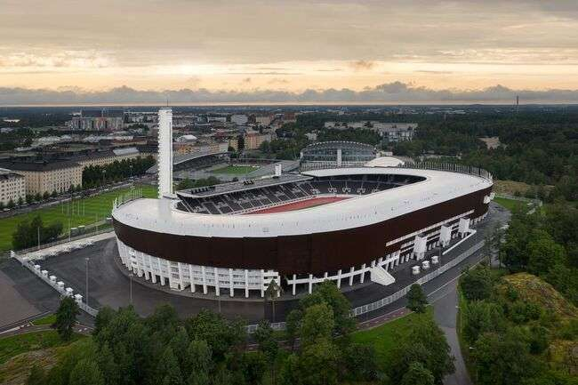
Today check out from your hotel and proceed for a guided city tour by driving past the city’s busy harbor and shipyards and down the coastal road by Embassy Park, seeing the colourful open-air market, you will see Senate Square, home to an elegant Lutheran Cathedral, as well as Esplanadi, a popular shopping avenue where many designer shops are located. Visit the Sibelius Monument dedicated to the Finnish composer Jean Sibelius. The tour will also take you down Mannerheim Street - Helsinki’s main street, to see the impressive Parliament building, the National Museum and Finlandia Hall; Alvar alto designed this beautiful concert hall and convention center. Later see the Olympic Stadium Helsinki constructed for its hosting of the 1952 Olympic Games. During your sightseeing tour of Helsinki you will also see the unique Rock Church which was built out of solid rock and capped with a copper dome. Later in the afternoon proceed to the pier to board the overnight cruise to Stockholm.
Olympic Stadium Helsinki
Overnight on board the Silja Line Cruise. (Breakfast, Lunch, Western Dinner)

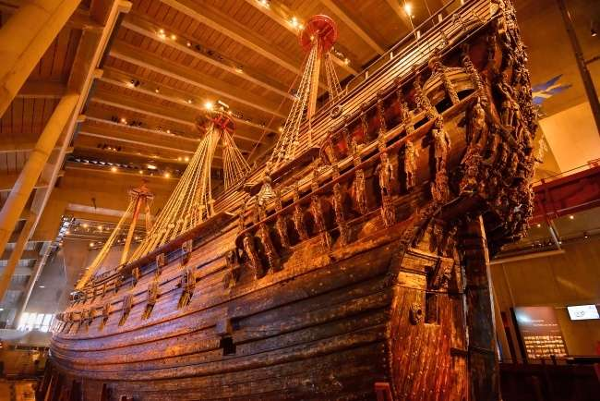
Day 3
Arrive in Stockholm.Entrance toDrottningholm Palace. Enjoy a guided city tour of Stockholm with a visit to the maritime museum – Vasa Museum. Enjoy a fascinating ride in the gondola up to SkyView of Stockholm.
Arrive in Stockholm, the Swedish capital. It is an open city for different perspectives and new ideas. Stockholm is famed for its iconic city hall, the world's first open-air museum and other historical sites. A vibrant destination where innovations in music, design, fashion and technology are born. Disembark from the cruise and proceed for guided tour of Drottningholm Palace. Experience a historic milieu of the highest standard. Drottningholm Palace is Sweden's best-preserved royal palace constructed in the seventeenth century, the permanent residence of the royal family, and one of Stockholm's three World Heritage Sites. Later meet your local guide at the hotel Lobby and proceed on a guided tour of the city of Stockholm often referred to as the Venice of the North. Visit Fjällgatan to see the magnificent view of the Swedish capital, spread out on 14 islands with Lake Mälar on one side and the Baltic Sea on the other. See the Old Town with its fascinating narrow cobble-stoned alleys, the Royal palace, the Cathedral, and the City Hall where the festivities of the annual Nobel Prize award takes place. Continue to the impressive Vasa Museum, this outstanding museum, which houses eight exhibitions, is one of Sweden’s most popular tourist attractions because of its beautifully preserved wooden warship that sank in Stockholm Harbour during her ill-fated maiden voyage in 1628. Go up on the gondola to the SkyView – Stockholm’s landmark, a world-class attraction that takes you to the top of the world’s largest spherical building for a fantastic view of Stockholm.
Vasa Museum

Vasa Ship Museum
Overnight in Stockholm. (Breakfast, Lunch, Dinner)

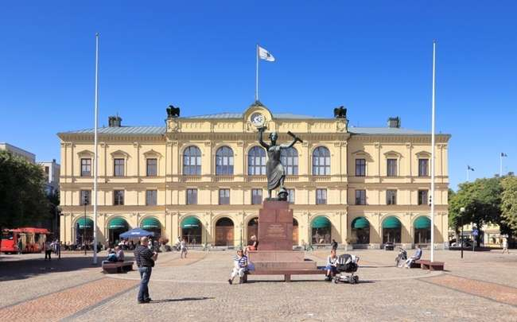
Day 4
Onto Oslo - the capital of Norway. Visit Karlstad – beautiful lakeside town in Sweden.
Sit back and relax in your coach as we drive to Oslo – the Norwegian capital. En route, visit the charming town of Karlstad, situated between Stockholm and Oslo. Bisected by the serene Klarälven River, Karlstad is known for its iconic Smiling Sun symbol, reflecting its warm and friendly atmosphere. Continue your journey to Oslo. On arrival, check in and relax in the comfort of your hotel, ready to explore the vibrant capital city.
Karlstad

Karlstad Square
Overnight in Oslo. (Breakfast, Lunch, Dinner)

Day 5
Enjoy a guided city tour of Oslo with Museum of Cultural History, Vigeland sculpture Park&visit to the top of Holmenkollen Ski Jump.
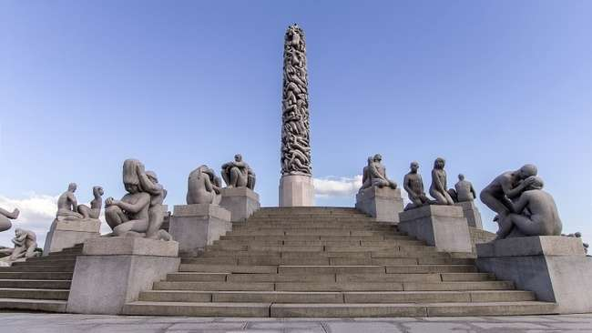
Begin your day with a guided tour of Oslo, exploring the highlights of Norway's capital city. Visit the iconic Vigeland Sculpture Park, home to an impressive collection of sculptures by Gustav Vigeland, showcasing the human experience through art. Continue to the Natural History Museum, where you can delve into Norway's rich natural heritage and discover fascinating exhibits. Enjoy a delicious lunch before heading to the famous Holmenkollen Ski Jump, an architectural marvel and a symbol of Norwegian skiing traditions. Afterward, embark on a scenic drive to Geilo, a charming mountain town nestled in the heart of Norway. Upon arrival, savor a hearty dinner and unwind for breathtaking landscapes.
Vigeland Sculpture Park
Overnight in Geilo. (Breakfast, Lunch, Western Dinner)

Day 6
Today embark on an exciting journey - Norway in Nutshell - The highlight of your tour.
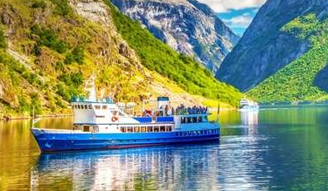
Post breakfast, check out from your hotel and embark on the unforgettable Norway in a Nutshell Tour, a journey that takes you through Norway's most breathtaking landscapes. Traverse majestic mountains on scenic train rides, glide through deep fjords on a serene cruise, and marvel at cascading waterfalls and picturesque villages. This iconic tour showcases the natural beauty and cultural charm that Norway is renowned for. After completing the tour, drive to the vibrant city of Bergen, the Gateway to the Fjords. Upon arrival, take time to unwind and soak in the unique atmosphere of this historic city, known for its colorful wharf, Bryggen, and stunning harbor views.
Norway in Nutshell – Fjord Cruise
Overnight in Bergen. (Breakfast, Lunch, Dinner)

Day 7
Guided tour of Bergen. Visit the Mt. Floyen by funicular.
Check out from your hotel and proceed for a guided tour of Bergen, exploring the city’s rich history and vibrant culture. Stroll through the UNESCO-listed Bryggen Wharf, admire its colorful wooden houses, and learn about Bergen’s maritime heritage. Next, visit Mt. Fløyen, ascending via the Fløibanen funicular for panoramic views of the city, fjords, and surrounding mountains. Enjoy a delightful lunch before boarding the Fjordline cruise from Bergen to Hirtshals. Spend the night on board the cruise, enjoying the relaxing ambiance as you sail through the stunning North Sea.
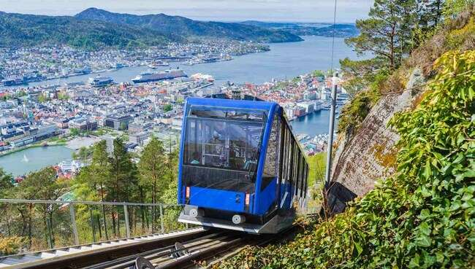
Overnight on board the Fjordline Cruise. (Breakfast, Lunch, Western Dinner)
Mt. Floyen by funicular

Day 8
Orientation tour of Aarhus with photo stop at the infinite bridge.Visit the H.C. Andersen Museum.
Arrive in Hirtshals and disembark from the cruise. Drive to Aarhus, where you’ll enjoy an orientation tour of the city, including a scenic photo stop at the Infinite Bridge, a stunning landmark offering picturesque views of the sea and sky. Enjoy a delightful lunch in Aarhus before continuing your journey to Odense, the birthplace of the famous fairy-tale author H.C. Andersen. Visit the H.C. Andersen Museum, where you can explore his life, stories, and creative legacy. Afterward, drive to Copenhagen, the vibrant capital of Denmark.
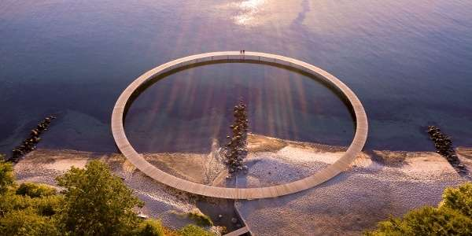
Overnight in Copenhagen. (Breakfast, Lunch, Dinner)
Infinite Bridge

Day 9
Guided tour of Copenhagen. Enjoy the Nyhaven cruise. Orientation tour of Roskilde. Visit Carlsberg brewery with Beer tasting. Entrance to Tivoli Garden.
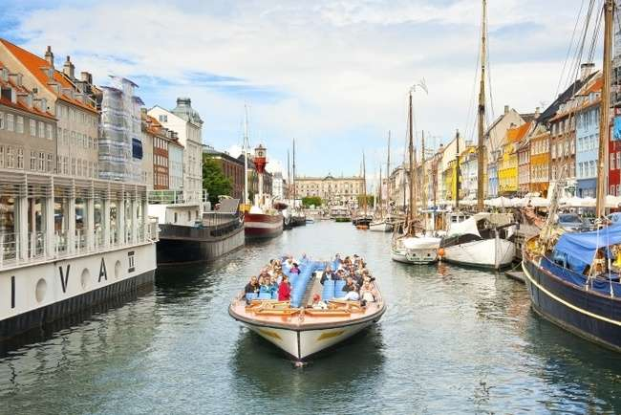
Start your day with a guided tour of Copenhagen, exploring the city’s highlights and iconic landmarks. Enjoy a scenic Nyhavn cruise, offering stunning views of Copenhagen from the water, with its colorful buildings and vibrant waterfront atmosphere. After the cruise, proceed to Roskilde for an orientation tour, where you’ll learn about the city’s rich history, including the impressive Roskilde Cathedral, a UNESCO World Heritage site. Continue your journey with a visit to the famous Carlsberg Brewery, where you’ll enjoy a guided tour and beer tasting, experiencing the rich flavors and heritage of one of Denmark’s most renowned breweries.Later in the evening, visit the famous Tivoli Gardens, one of Copenhagen’s most famous attractions, known for its stunning gardens, thrilling rides, and enchanting atmosphere.
Nyhavn Canal Cruise
Overnight in Copenhagen. (Breakfast, Lunch, Dinner)

Day 10
Fly back home
Your memorable Holiday ends, today it’s time to fly back home. Say goodbye to the wonderful new friends you have made on the tour. Check out and depart for the Airport with pleasant memories of your European trip which you will cherish for a lifetime. (Breakfast)

Inclusion: Sightseeing and excursions

FINLAND
Helsinki

- Guided city tour of Helsinki
- Visit Rock Church
- Visit the Sibelius Monument

BOARD OVERNIGHT SILJA LINE CRUISE TO STOKHOLM

SWEDEN
Stockholm

- Guided City tour of Stockholms
- Visit to the maritime museum – Vasa Museum
- Ride the Gondola up to SkyView
- visit the charming town of Karlstad

Dorttningholm
- Entrance to Drottningholm Palace

NORWAY
Oslo
- Guided City Tour of Oslo
- Visit Vigeland Sculpture Park
- Museum of Cultural History
- Visit Holmenkollen Ski Jump

EXCISTING JOURNEY THROUGH NORWAY IN NUTSHELL

Bergen
- Guided City tour of Bergen
- Visit the Mt. Floyen
- Fløibanen funicular for panoramic views

BOARD OVERNIGHT FJORD CRUISE TO DENMARK

DENMARK
Aarhus
- Orientation tour of Aarhus
- Photo stop at the Infinite Bridge
- Visit the H.C. Andersen Museum

Copenhagen
- Guided City tour of Copenhagen
- Enjoy the Nyhaven cruise
- Visit Carlsberg brewery with Beer tasting
- Entrance to Tivoli Garden

Roskilde
- Orientation tour of Roskilde

Accommodation:
- 01 night accommodation in Scandic Aviapolis or similar in Helsinki
- 01 Night onboard Silja Cruise Line to Stockholm
- 01 night accommodation in Hotel Qulaity Globe or similar in Stockholm
- 01 night accommodation in Thon Hotel or similar in Oslo
- 01 night accommodation in Vestlia resort or similar in Geilo
- 01 night accommodation in Hotel Quality Edvard or similar in Bergen
- 01 night onboard FjordLine Cruise to Aarhus
- 02 nights accommodation in AC Bella Sky or similar in Copenhagen

Meals
- Daily Continental Buffet Breakfast.
- 08 Indian Jain/Vegetarian/Non-Vegetarian Lunches.
- 07 Indian Jain/Vegetarian/Non-Vegetarian Dinners.
- 02 Continental Dinner on the Overnight Cruise.
- Daily Mineral Water Bottle (500ml)

Instruction for Arrival & Departure Coach Transfers:
Helsinki (HEL Airport) Arrival Transfer: Flight landing time should be between 08 AM – 1300 HRS
Copenhagen (CPH Airport) Departure Transfer: The coach will drop at CPH Airport by 1100 AM.

IMP Notes for Transfers:
- Please advise your client that there may be waiting up to 02 Hours (Post reaching in arrival hall) for arrival transfers.
If flight timings are before / after the suggested timing, client has to arrange his private Driver Tips:
- Tips to coach drivers per person, per day 5 EURO will be charge and added in the final payments a for the duration of the tour.

Payment Policy:
100, 000.00 INR per person at the time of the booking
IF we booked your air tickets, Full payment of the cost within 1 week of the ticket booking
75 days prior to tour departure 75000.00 INR per person.
60 Days prior to tour departure full payment with tips 5 euro per person per dayshould be
paid and cleared from our bank.
IF two travelers sharing room in tour and one of them drop out/ cancelled the tour,
remaining traveler charge as a single traveler.

Cancellation Policy with full airfare cost:
90 days prior to tour departure 40,000.00 INR per person at the time of cancellation
IF we booked your air tickets, Full payment.
75 days prior to tour departure 150000.00INR per person.
60 – 44 Days prior to tour departure full payment.
Important Notes:
GST 5%is applicable on total cost
TCS -5to 20% on total tour cost as per Indian govt, rules and regulations.
Exchange rate for Euro= 96 INR will be charge at rate of the final payment time.
All Hotel Room category is standard room (Basic category) Hotel is not
In city center or downtown.
We are not giving refund of any sightseeing closed due to maintenance
or weather, political, riots and /or other situations not under our control.
Vehicle Policy:
During Sight Seeing driver will try his best to park as much closer He
can, from there guest Has to make His way by walk or they have To
make their own transfer If require any.In caseofcoachbreakdown
TRAVELGROCERYDMC.PVT.LTD and tour providerswilldoTheir
best effort to fix the problem as soon as possible. But make sure there
will be no refund for inconvenience cause. Request to all guest please
don’t leave Any unattended Item in vehicle while leaving the vehicle.
What your tour price does not include:
- The cost of the Airfare, Passport, POE charges, Visa charges, Overseas Travel Insurance, etc.
- Any expenses of personal nature such as Porterage, Laundry, and Alcohol, Food or Drink not in the regular menus provided by us, mini bar and telephone calls
- Any extra meals not included in the itinerary. Meals are pre - set and a choice of menu is not available, No refund of any unused meals, services, sightseeing, etc.
- Cost of excursions, city sightseeing, entrance fees and local guides availed of by the passengers, other than that mentioned in ‘What your tour price includes’
- GST, TCS and other taxes as applicable
- Anything which is not specified in the Itinerary
- Any item and services not mentioned in Inclusions.
- Tips to coach drivers per person, per day 5 EURO will be charge and added in the final payments a for the duration of the tour.

IMP Notes for Transfers:
- Please advise your client that there may be waiting up to 02 Hours (Post reaching in arrival hall) for arrival transfers.
- If flight timings are before /after the suggested timing, client has to arrange his private transfers on direct payment basis. We will not reimburse any cost for private transfers.

NOTES:
- A person below 12 years of age on the entire tour will be considered a child
- As a 3rd person in a triple room, most hotels use rollaway beds and room size may be the same as the double room
- Tours will operate subject to all Government regulations
- All Local taxes, entrances and services are calculated as on 1st October 2021, any increase in local taxes, entry tickets and other services has to be borne and paid by the traveller/agent.
- All transfers and extensive sightseeing with entrance fees (as specified in the itinerary) will be done in an air-conditioned coach
- On reaching Eiffel Tower, if there is a very long queue, we will be taking you to the Montparnasse tower.
- It is suggested to carry One check in bag and one hand bag per person only, due to limited boot space in the coach
- Services of our tour manager or local representatives, while on tour
- On some occasions, you may have to join another group in case your group does not have adequate members
- A local representative or your coach driver may only be there to assist you during your initial part of the tour
- Land surcharges applicable on certain departure dates which will be notified
- If certain sightseeing/excursions are closed, then alternate sight- seeing will be arranged.
- Kindly note that on certain departure dates the tour routing could change. In some tours, there is also a possibility that the tour could operate in reverse itinerary. However, you will not miss any sightseeing or excursions that are mentioned in the itinerary unless its closed due to a holiday. Your Tour Manager will notify you the same
- In case of inordinate delays and strict driving laws, packed dinner may be provided on that day
- Please check with your Sales representative for final details
- In case of any increase in any taxes in Europe, there would be a change in price which will be justified
- We reserve the right to claim from the passengers, any additional expenses incurred due to delay or changes in the schedule of trains, flights, coach, cruise or other services
- We reserve the right to change any itinerary for operational reasons and reasons beyond the control of us due to Force Majeure related to weather conditions, strike, etc. Force Majeure related to weather conditions, strike, etc.
- We shall not accept any liability or responsibility for any damages, loss, injury, accident, death, delay, breakdown or irregularity, which may occur during the tour, due to weather conditions, strikes, war, quarantine and or any other cause whatsoever and all such loss or expenses must be borne by the passenger
- Tours are operated subject to Reserve Bank of India / Government of India regulations
- Tour cost is payable in EURO out of your BTQ entitlement of the passengers

DirectJoiningGuestHavetoarrangehoteltransferforcheckinandcheckout
dayby themselves. operation of a group Tour is a Subject to minimum participation of 25paying adult Passenger. Any increase in visa fee /airfare /fuel price /change in government Regulations taxes Etc. will affect your tour cost.
Tour itinerary will be strictly followed as Per timing. In unavoidableSituationour
tourmanagercanmakechangeswiththe concernofHead Office.
TourmanagerIsnotauthorizingtomakechangesinItinerary asPerguestconvenience.Incaseof anydeportationduetoImmigrationand CustomClearance.TRAVEL GROCERY DMC PVTLTD and tour providers will not be responsible. There will be no refund for tour package. Optional Sightseeing have tobePre-bookwithan additionalCost.

ThereIsNo Refundforany unutilizedServices.
ItinerarycostIsperpersonontwinSharingbasis.It Includeonlythoseactivitieswhicharelistedin thesame.

ItinerarycostdoesnotInclude anyPersonalNatureExpenses.Such as tips, Misc.Expenses,Laundry,Liquor,Porterage, Medical expenses, travel insurance Etc.Internationaltourguestmusthaveto reachairportbefore3Hrs.ofdeparturetime.

ForNRI–PassengersstayinginIndiafor moreThan180dayswillhavetotakePolice ClearanceCertificatefromCommissioner ofPoliceforwhichTRAVELGROCERYDMC.PVT.LTD and tour providerswillnotberesponsible.

PassengersarerequestedtosubmitXeroxcopyofpassport alongwithpageShowing arrivalstampinIndia.

- transfers on direct payment basis. We will not reimburse any cost for private transfers.

