Japan With S. Korea Extension
Only Japan 8 Nts. -9 Days Optional: S. Korea 3 Nts.
Tour Start Dates in Japan

DAY 1: ARRIVE TOKYO

Today we arrive Narita International airport and met by our tour representative and drive to hotel. After check in we relax in the hotel and meet again in the Evening for Dinner.

Hotel : Asakusa View / Prince Shiodome Or Similar Dinner : Indian Dinner
DAY 2: TOKYO TOUR

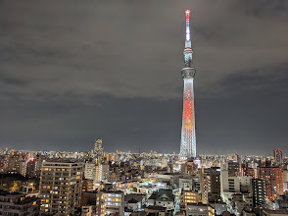
Today after breakfast we depart in the morning for a full day tour covering Sensoji Temple & Nakamise Shopping Arcade – Imperial Palace – Tokyo Tower (Lower Observation Deck). Followed by Lunch. Post Lunch we visit Ginza where we have free time for Shopping. Later dinner and transferred back to the hotel for overnight.

Hotel : Asakusa View / Prince Shiodome Or Similar
Breakfast: Yes Lunch: Indian Dinner: Indian

DAY 3: TOKYO – MT FUJI – HAKONE – TOKYO

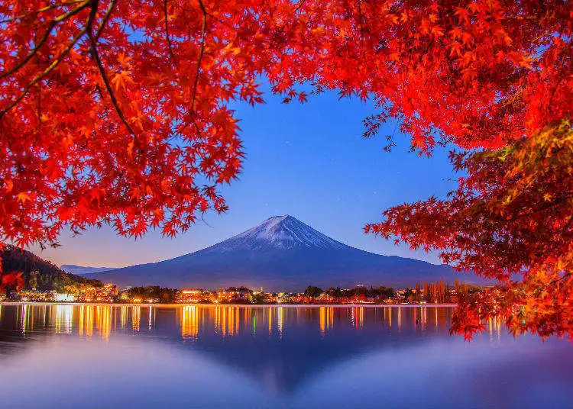
After breakfast we visit the Mt. Fuji is an active volcano about 100 kilometres southwest of Tokyo. Commonly called “Fuji-san” it’s the country’s tallest peak, at 3776 meters. A pilgrimage site for centuries, it’s considered one of the Japan’s 3 sacred mountains. Post Lunch we visit Hakone visiting Valley – Hakone Ropeway, Cruise on Lake Ashi. Later we are transferred back to Tokyo followed by dinner.

Hotel : Asakusa View / Prince Shiodome Or Similar
Breakfast: Yes Lunch: Indian Dinner: Indian

DAY 4: TOKYO – TAKAYAMA

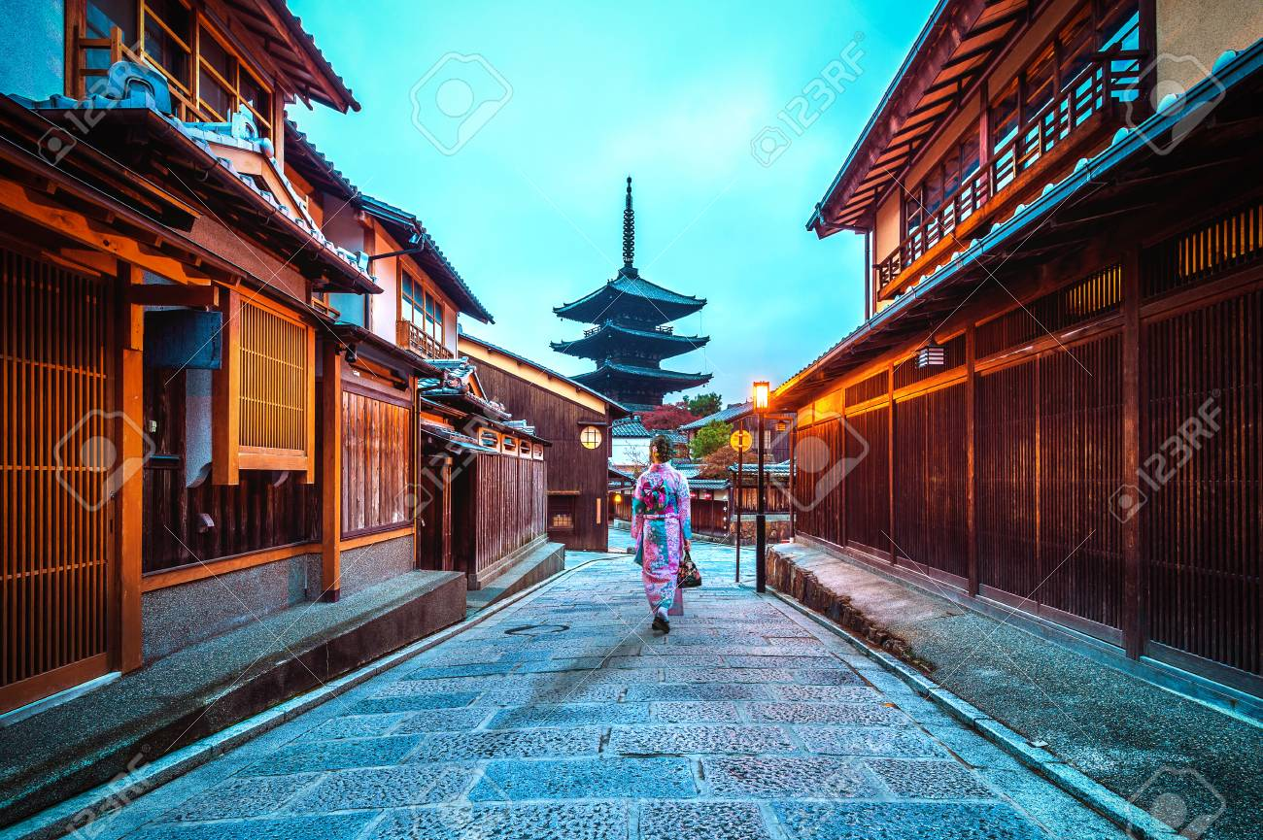
This morning we check out of our hotel and transferred to Takayama. Where we visit (Takayama) – Kami-Sannomachi Historical District – Hirata Folk Art Museum – Yatai Kaikan (Festival Floats Exhibition Hall). Later we transferred to our hotel.
Hotel: Associa Takayama Or Similar
Breakfast: Yes Lunch: Indian Dinner: Indian
Breakfast at the hotel Assemble at hotel lobby and start tour by chartered coach with local guide. Visiting (Shirakawago) - Wada House Proceed to Gokayama Visiting (Gokayama) - Demonstration of traditional Japanese papermaking techniques. Continue to Kanazawa Lunch at local Indian restaurant. Visiting (Kanaza- wa) - Nagamachi Samurai District (Nomura Family House) - Higashi Chaya District Dinner at local Indian restaurant. Check in your hotel in Kanazawa.

DAY 5: TAKAYAMA – SHIRAKAWAGO – KANAZAWA

Hotel: MyStay Kanazawa Or Similar
Breakfast: Yes Lunch: Indian Dinner: Indian
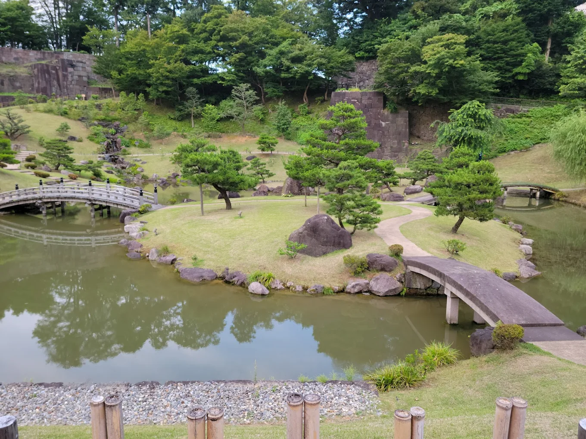
DAY 6: KANAZAWA – OSAKA
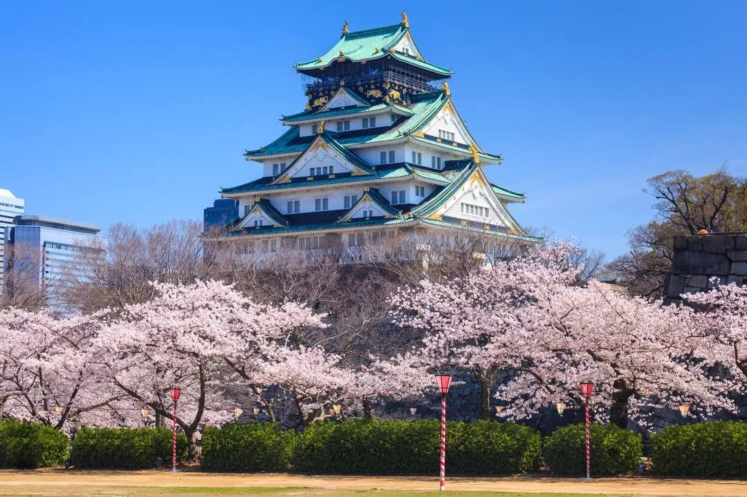
Breakfast at the hotel Assemble at hotel lobby and start tour by chartered coach with local guide.
Visiting (Kanazawa) - Oumicho Market - Kenrouen Garden Lunch at local Indian restaurant. Drive to
Osaka Visiting (Osaka) - Shinsaibashi Area Dinner at local Indian restaurant. Check in your hotel in
Osaka
Breakfast: Yes Lunch: Yes Dinner: Yes
DAY 7:OSAKA – KYOTO – NARA – OSAKA
Breakfast at the hotel. Later Assemble at hotel lobby and start tour by chartered coach with local guide. Visiting (Kyoto) - Kinkakuji Temple (Golden Pavilion) - Nijo Castle - Kiyomizudera Temple - Gion District Lunch at local Indian restaurant. Drive to Nara Visiting (Nara) - Todaji Temple (Great
Buddha) - Nara Park (Deer Park) Back to Osaka Dinner Own
Hotel: Karaska Grande Shin Osaka OR Similar
Breakfast: Yes Lunch: Yes Dinner: Own
DAY 8: OSAKA – HIROSHIMA – OSAKA
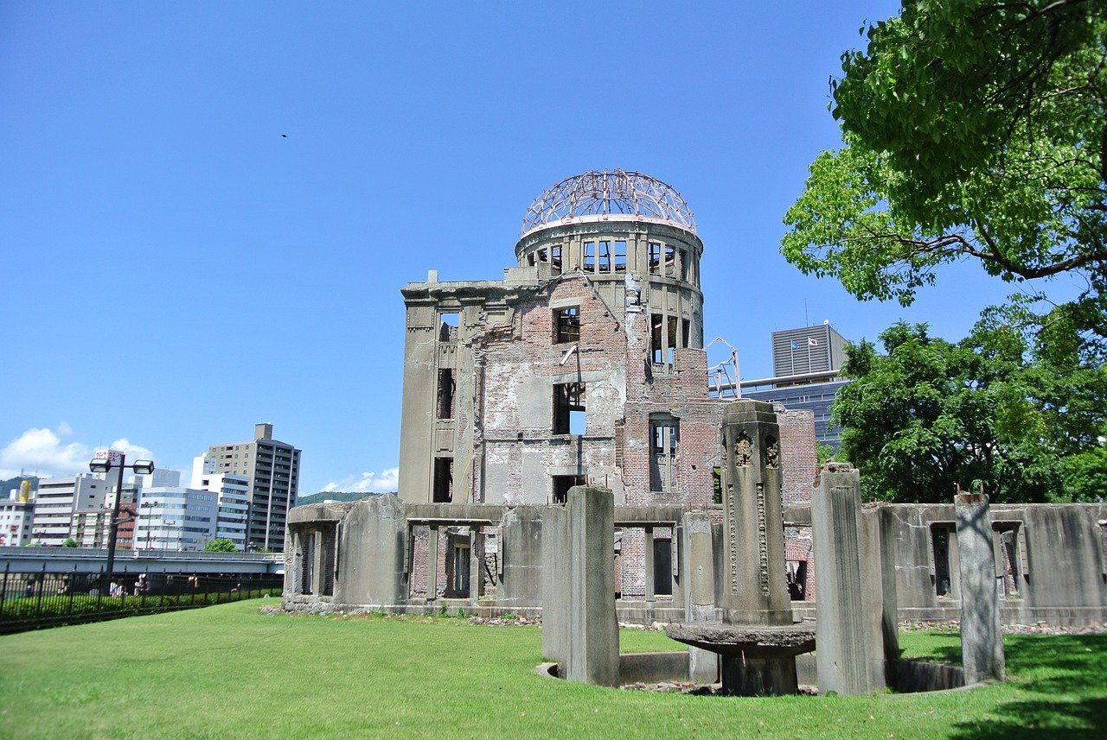
Breakfast at the hotel, later Assemble at hotel lobby and walk to Shin Osaka Station with local \guide. Take a bullet train from Shin Osaka Station to Hiroshima Station. Upon arrival at Hiroshima Station, start an excursion in Hiroshima. Visiting (Hiroshima) - Peace Memorial
Park & Museum - Atomic Bomb Dome (Photo Stop Only) Lunch at local Indian restaurant.
Back to Hiroshima Station. Take a bullet train from Hiroshima Station to Shin Osaka Station. Arrive at Shin Osaka Station, take you to sightseeing in Osaka by public transportation with local guide. Visiting (Osaka) - Umeda Sky Building Observation Deck Dinner at local Indian restaurant. Back to hotel in Osaka.

Hotel: Karaska Grande Shin Osaka OR Similar
Breakfast: Yes Lunch: Yes Dinner: Yes

DAY 9: OSAKA – FLY OUT Only Japan tour will be end today
Today after breakfast we are transferred to the airport to take our flight back to home.
S. Korea-

DAY 9: ARRIVE SEOUL
Today we will arrive Incheon Airport and met by our tour representative and transferred to Seoul and visit DDP. The Dongdaemum Design Plaza, abbreviated as DDP, is a major urban development landmark in Seoul, South Korea designed by Zaha Hadid and Samoo, with a distinctively neo futuristic design characterized by the “powerful, curving forms of elongated structures”. Late we are transferred to the hotel.

Dinner: Yes

Day 10:SEOUL TOUR:Today after breakfast we depart for a full day city tour of Seoul. Firstly, visiting Cheong Wa Dae, also known as the Blue House, is a public park that formerly served as the executive office and official residence of the president of Seoul Korea. Later followed by Lunch at an Indian
restaurant. Post Lunch we visit Gyeongbok palace which was the main royal palace of the Joseon dynasty. Built in 1395, it is located in northern Seoul, South Korea. Later we visit the Bukchon Hanok Village. Followed by dinner.
Breakfast: Yes Lunch: Yes Dinner: Yes

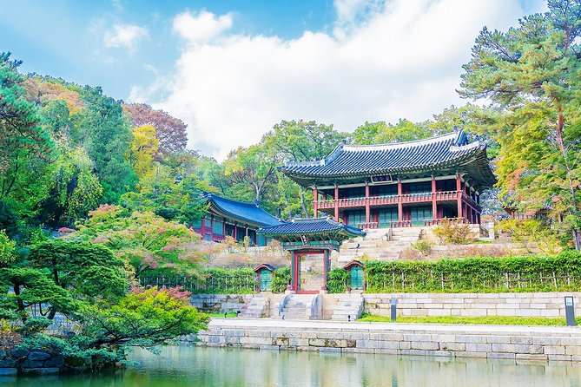

DAY 11: SEOUL – Nami Island or DMZ TOUR - SEOUL

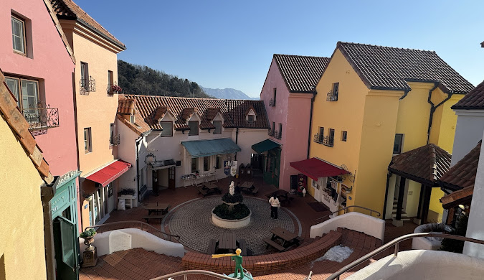

After Breakfast We will depart we will visit little paris, Nami Island Afternoon at Nami Island (we are transferred to Gap Yeong wharf to take a ferry to Nami Island. Nami Island is a half-moon shaped river island located in Chuncheon, Gangwon Province, South Korea, formed as the land around it was inundated by the rising water of the North Han River as the result of the construction of Cheong Yeong Dam in 1944.

*** If any reason Nami Island closed we will go to full day tour DMZ (S. Korea and N. Korea border) We will notify you when we arrive in S. Korea make sure you take your passport with you. (if you forget your passport you have to wait in bus)***

Breakfast: Yes Lunch: Yes Dinner: Yes

DAY 12:SEOUL – FLY OUT
Today after breakfast we are transferred to the airport to take our flight back home.

Breakfast: Yes

Driver Tips:
- Tips to coach drivers per person, per day 5 EURO will be charge and added in the final payments a for the duration of the tour.

Payment Policy:
100, 000.00 INR per person at the time of the booking
IF we booked your air tickets, Full payment of the cost within 1 week of the ticket booking
75 days prior to tour departure 75000.00 INR per person.
60 Days prior to tour departure full payment with tips 5 euro per person per dayshould be
paid and cleared from our bank.
IF two travelers sharing room in tour and one of them drop out/ cancelled the tour,
remaining traveler charge as a single traveler.

Cancellation Policy with full airfare cost:
90 days prior to tour departure 40,000.00 INR per person at the time of cancellation
IF we booked your air tickets, Full payment.
75 days prior to tour departure 150000.00INR per person.
60 – 44 Days prior to tour departure full payment.

Important Notes:
GST 5%is applicable on total cost
TCS -5to 20% on total tour cost as per Indian govt, rules
Exchange rate for Euro= 96 INR will be charge at rate of the final payment time.
All Hotel Room category is standard room (Basic category) Hotel is not
In city centre or downtown.
We are not giving refund of any sightseeing closed due to maintenance
or weather, political, riots and /or other situations not under our control.
Vehicle Policy:
During Sight Seeing driver will try his best to park as much closer He
can, from there guest Has to make His way by walk or they have To
make their own transfer If require any.In caseofcoachbreakdown
TRAVELGROCERYDMC.PVT.LTD and tour providerswilldoTheir
best effort to fix the problem as soon as possible. But make sure there
will be no refund for inconvenience cause. Request to all guest please
don’t leave Any unattended Item in vehicle while leaving the vehicle.
What your tour price does not include:
- The cost of the Airfare, Passport, POE charges, Visa charges, Overseas Travel Insurance, etc.
- Any expenses of personal nature such as Porterage, Laundry, and Alcohol, Food or Drink not in the regular menus provided by us, mini bar and telephone calls
- Any extra meals not included in the itinerary. Meals are pre - set and a choice of menu is not available, No refund of any unused meals, services, sightseeing, etc.
- Cost of excursions, city sightseeing, entrance fees and local guides availed of by the passengers, other than that mentioned in ‘What your tour price includes’
- GST, TCS and other taxes as applicable
- Anything which is not specified in the Itinerary
- Any item and services not mentioned in Inclusions.
- Tips to coach drivers per person, per day 5 EURO will be charge and added in the final payments a for the duration of the tour.

Instruction for Arrival & Departure Coach Transfers:
Arrive at Tokyo
Departure from Osaka
Who joining for S. Korea they will Departure from Seoul.
IMP Notes for Transfers:
- Please advise your client that there may be waiting up to 02 Hours (Post reaching in arrival hall) for arrival transfers.
- If flight timings are before /after the suggested timing, client has to arrange his private transfers on direct payment basis. We will not reimburse any cost for private transfers.
NOTES:
- A person below 12 years of age on the entire tour will be considered a child
- As a 3rd person in a triple room, most hotels use rollaway beds and room size may be the same as the double room
- Tours will operate subject to all Government regulations
- All Local taxes, entrances and services are calculated as on 1st October 2021, any increase in local taxes, entry tickets and other services has to be borne and paid by the traveller/agent.
- All transfers and extensive sightseeing with entrance fees (as specified in the itinerary) will be done in an air-conditioned coach
- On reaching Eiffel Tower, if there is a very long queue, we will be taking you to the Montparnasse tower.
- It is suggested to carry One check in bag and one hand bag per person only, due to limited boot space in the coach
- Services of our tour manager or local representatives, while on tour
- On some occasions, you may have to join another group in case your group does not have adequate members
- A local representative or your coach driver may only be there to assist you during your initial part of the tour
- Land surcharges applicable on certain departure dates which will be notified
- If certain sightseeing/excursions are closed, then alternate sight- seeing will be arranged.
- Kindly note that on certain departure dates the tour routing could change. In some tours, there is also a possibility that the tour could operate in reverse itinerary. However, you will not miss any sightseeing or excursions that are mentioned in the itinerary unless its closed due to a holiday. Your Tour Manager will notify you the same
- In case of inordinate delays and strict driving laws, packed dinner may be provided on that day
- Please check with your Sales representative for final details
- In case of any increase in any taxes in Europe, there would be a change in price which will be justified
- We reserve the right to claim from the passengers, any additional expenses incurred due to delay or changes in the schedule of trains, flights, coach, cruise or other services
- We reserve the right to change any itinerary for operational reasons and reasons beyond the control of us due to Force Majeure related to weather conditions, strike, etc. Force Majeure related to weather conditions, strike, etc.
- We shall not accept any liability or responsibility for any damages, loss, injury, accident, death, delay, breakdown or irregularity, which may occur during the tour, due to weather conditions, strikes, war, quarantine and or any other cause whatsoever and all such loss or expenses must be borne by the passenger
- Tours are operated subject to Reserve Bank of India / Government of India regulations
- Tour cost is payable in EURO out of your BTQ entitlement of the passengers

DirectJoiningGuestHavetoarrangehoteltransferforcheckinandcheckout
dayby themselves. operation of a group Tour is a Subject to minimum participation of 25paying adult Passenger. Any increase in visa fee /airfare /fuel price /change in government Regulations taxes Etc. will affect your tour cost.
Tour itinerary will be strictly followed as Per timing. In unavoidableSituationour
tourmanagercanmakechangeswiththe concernofHead Office.
TourmanagerIsnotauthorizingtomakechangesinItinerary asPerguestconvenience.Incaseof anydeportationduetoImmigrationand CustomClearance.TRAVEL GROCERY DMC PVTLTD and tour providers will not be responsible. There will be no refund for tour package. Optional Sightseeing have tobePre-bookwithan additionalCost.

ThereIsNo Refundforany unutilizedServices.
ItinerarycostIsperpersonontwinSharingbasis.It Includeonlythoseactivitieswhicharelistedin thesame.

ItinerarycostdoesnotInclude anyPersonalNatureExpenses.Such as tips, Misc.Expenses,Laundry,Liquor,Porterage, Medical expenses, travel insurance Etc.Internationaltourguestmusthaveto reachairportbefore3Hrs.ofdeparturetime.

ForNRI–PassengersstayinginIndiafor moreThan180dayswillhavetotakePolice ClearanceCertificatefromCommissioner ofPoliceforwhichTRAVELGROCERYDMC.PVT.LTD and tour providerswillnotberesponsible.

PassengersarerequestedtosubmitXeroxcopyofpassport alongwithpageShowing arrivalstampinIndia.

