EUROPEGRAND TOUR
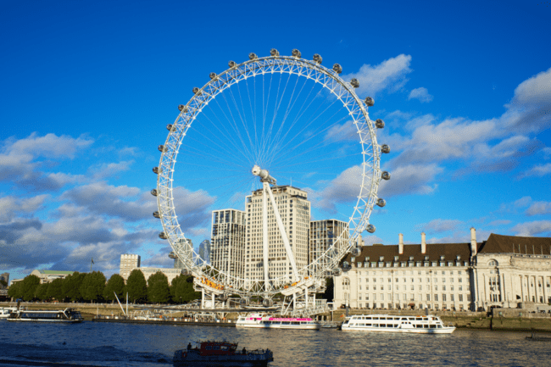
14 NIGHTS & 15 DAYS

- Visit 10 countries in 15 days: United Kingdom, France, Belgium, The Netherlands, Germany, Switzerland, Liechtenstein, Austria, Italy and Vatican City
- All Important attractions and sightseeing included with some new additions. Madame Tussauds, London Eye, Lord’s Cricket Ground, Eurostar train from London to Paris, Eiffel Tower 3rd level, Guided tour of Versailles palace, Full day at Disneyland® Paris, River Seine Cruise, Paris by Night tour, Mini Europe, Keukenhof Gardens (till 11th May), Visit traditional village showcasing windmills and wooden houses, Heidelberg Alstadt, Excursion to Jungfrau included, Entrance to Mt. Titlis, Lindt Home of Chocolate, Mini Train ride in Vaduz, Swarovski Crystal Museum, Visit to St. Mark’s Square with Gondola Ride, Photo stop at Leaning Tower of Pisa and entrance to Vatican Museum & Sistine Chapel with Local guide.
- Guided tour in London, Paris, Vaduz, Florence, & Vatican Museum
- Services of a Professional & Knowledgeable Tour Manager accompanying you throughout the tour
- Accommodation in superior 4-star hotels
- Daily Continental buffet breakfast.
- Delicious unlimited meals with variety of Jain, Veg and Nonveg cuisine (Indian / Local) included as per itinerary.
- Daily mineral water bottle (500ml) per person.
Tips to coach drivers per person, per day 5 EURO will be charge and added in the final
payments a for the duration of the tour.

Delights
- A glass of Champagne in France
- Souvenir in Holland
- Waffle in Brussels
- Black Forest Cake in Germany
- Chocolate Milk shake in Swiss
- Pizza and Pasta in Italy
- Gelato Ice cream in Italy
- Masala tea and Dinners in the hotel in select cities

Day 1
Arrive into London, the capital of England and the United Kingdom.
Greetings! Today marks the commencement of our journey as we embark on a flight to a captivating city renowned for its vibrant culture, cosmopolitan atmosphere, and intriguing history – London, the capital of England. Upon arrival, you will be warmly welcomed by our amiable and knowledgeable Tour Manager, who will guide you to your hotel and facilitate a smooth check-in process. Take some time to unwind and enjoy the comforts of your accommodation.
Overnight stay at the hotel in London. (Dinner)

Day 2
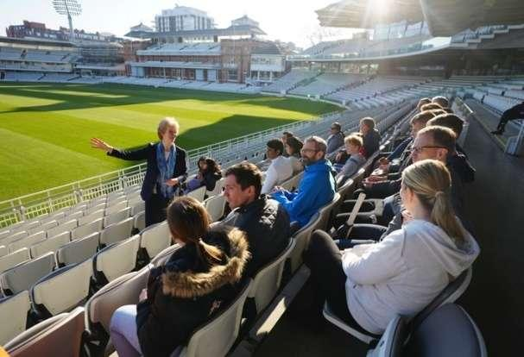
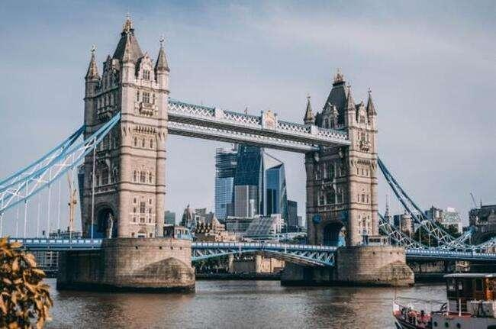
Guided city tour of London with Changing of Guards. Visit the legendary Lord’s Cricket Ground. Ride the London Eye.
Lord’s Cricket Ground
Tower Bridge

Post breakfast, we drive to explore the city of London with our expert local guide. You will see important landmarks like the Big Ben, Houses of Parliament, Westminster Abbey, Trafalgar Square, Piccadilly Circus, Tower Bridge, River Thames, Hyde Park and many more. Witness the Changing of the Guards at Buckingham Palace (subject to operation). Next we proceed to visit one of the iconic cricketing venues in London – the Lord’s Cricket Ground. In Lord’s you will have an opportunity to go behind the scenes at the ‘Home of Cricket’, and to experience some of the most inspiring views in sport. See the iconic parts of the ground including the Grade II*-listed Victorian Pavilion, the world-famous Long Room, the Players’ Dressing Rooms, and the MCC Museum, home of the Ashes Urn – cricket’s best-known artefact. Complete your visit with a delightful lunch, soaking in the atmosphere of this storied ground—a must for any cricket enthusiast! Later we visit London eye, one of the many iconic highlights of the city. Enjoy scenic views of the city while you ride the London eye. It is one of the most popular tourist attractions in the United Kingdom, standing at 135 meters tall overlooking the river Thames and the beautiful city of London.
Overnight stay at the hotel in London. (Breakfast, Lunch, Dinner)

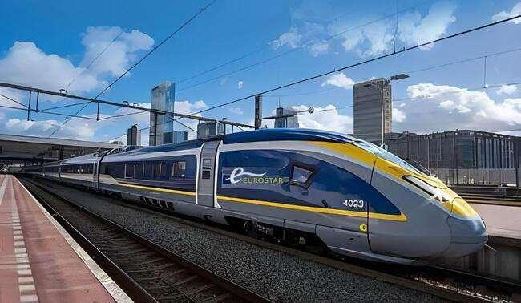
Eurostar Train – London to Paris
Day 3
Visit to the famous Madame Tussauds Wax museum. Proceed to Paris - the City of Romance, Lights and Glamour.
Check out of your hotel as we proceed to visit the renowned Madame Tussauds wax museum. Be enthralled by the world’s largest wax collection of famous personalities. Later we proceed to travel by high speed train from London to Paris. Eurostar is a high-speed train service connecting London with Paris through the Channel Tunnel. En route enjoy the English and French Countryside. Offering a swift and efficient journey, it provides a seamless travel experience between these iconic European cities. After disembarking proceed to the fashionable and elegant city Paris, known for its haute couture, renowned museums, breath-taking beautiful monuments and sensational cabarets.
River Seine Cruise
Overnight stay at the hotel in Paris. (Breakfast, Lunch, Dinner)

Versailles Palace
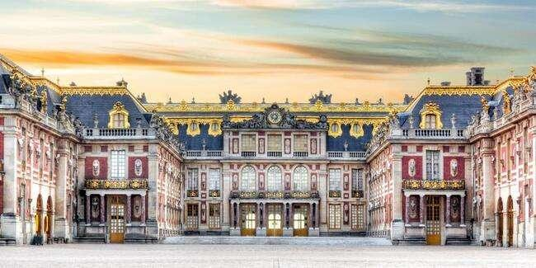

Day 4
Experience a guided city tour of Paris, including a visit to the Eiffel Tower's 3rd (Top) Level. Visit the Palace of Versailles, a testament to the pinnacle of French 17th-century artistry and achievement.
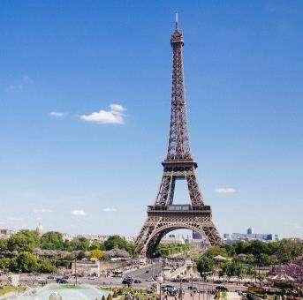
Today, we embark on a guided city tour of Paris, where you'll have the opportunity to marvel at some of the most exquisite Parisian attractions. Our journey will take us through iconic locations such as Place Vendôme, Place de l’Opéra Garnier, Musée d’Orsay, Place de la Concorde, the renowned Champs Elysées, the majestic Arc de Triomphe, Alexander Bridge, Les Invalides, and many more. Following our city exploration, we'll ascend to the 3rd Level of the iconic Eiffel Tower, providing us with a breathtaking panoramic view of the city. The Eiffel Tower, distinguished by its iconic tapering cast iron tip, not only symbolizes Paris but also represents the essence of all France.
Our adventure continues with a visit to the Palace of Versailles, an internationally acclaimed masterpiece located in Versailles, approximately 12 miles (19 km) west of Paris, France. This magnificent palace is the property of the French Republic and has been under the stewardship of the Public Establishment of the Palace, Museum, and National Estate of Versailles, overseen by the French Ministry of Culture since 1995. Drawing in a staggering 15,000,000 visitors each year, the Palace, Park, and Gardens of Versailles rank among the most sought-after tourist destinations globally.
Eiffel Tower
Overnight stay at the hotel in Paris. (Breakfast, Lunch, Dinner)

(IMP NOTE - Please note that access to the Eiffel Tower's 3rd level is contingent on its operational status. If it happens to be closed during our visit, we will make the necessary adjustments and proceed to explore the 2nd level instead. Your experience will still be enriched by the fantastic views and the charm of the Eiffel Tower.)

**Day 4 & Day 5 can get swapped based on the availability of ticket slots of the tours**

DAY 5
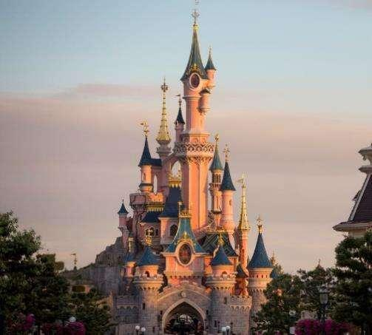
Indulge in a day of excitement at Disneyland® Paris, where you have the choice of exploring either Disney® Park or Walt Disney Studios® Park. Enjoy a romantic cruise along the picturesque Seine River. Paris by Night Tour.
Today promises a day filled with excitement at this beloved amusement park—a perfect destination to unwind and relish a variety of thrilling rides and cinematic experiences with your loved ones. You have the option to choose between Disney Park, where you can watch fairy tales come to life across five captivating realms brimming with classic attractions, dazzling shows, and lively street parades featuring beloved Disney Characters. Alternatively, you can explore the Walt Disney Studios Park and be awestruck by impressive stunt performances, witness the magic of film production, and behold the real-life sets used in blockbuster movies.
Later in the day, we'll treat you to a romantic cruise along the Seine River, renowned as one of the world's most scenic journeys. Along the way, you'll be captivated by the sight of exquisite landmarks such as Notre Dame, the Eiffel Tower, the Louvre, the Orsay Museum, and many more. Glide gracefully under one picturesque bridge after another, enjoying views of the finest monuments in the heart of bustling Paris. After the cruise, we proceed for a captivating and enchanting experience to witness the City of Light in all its night time
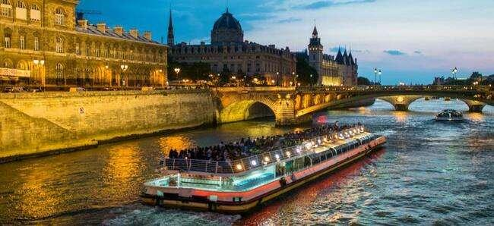
splendour. Paris, often referred to as the "City of Light". See some of Paris's most famous landmarks, all bathed in a soft, golden glow. These might include the Eiffel Tower, Notre-Dame Cathedral, the Louvre Pyramid, Place de la Concorde, Champs-Élysées, and the Arc de Triomphe.
Disneyland Paris
Overnight stay at the hotel in Paris. (Breakfast, Lunch, Dinner)

(Important Note – Keeping in mind the logistical consideration the Tour Manager reserves the right to alter or change the itinerary. However, we will ensure that all the attractions are covered)
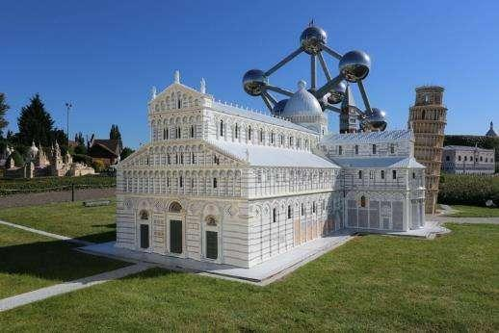
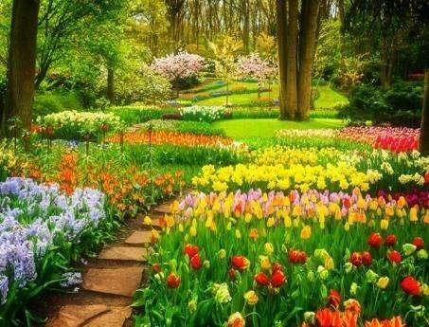
Mini Europe
Keukenhof Gardens till 11th May

Day 6

Onto Brussels. Visit Grand Place and Manneken Pis statue. Visit the miniature park – Mini Europe.
Today, our journey takes us to Brussels, known as the headquarters of the European Union and the capital of Belgium. Upon arriving in Brussels, our first stop is at the Grand Place, which is widely regarded as one of Europe's most beautiful squares. Here, you'll encounter the medieval Town Hall and the renowned Manneken Pis statue. Next, we proceed to visit Mini Europe, a captivating miniature park. Discover a unique miniature world. Mini-Europe is a park where all the wonders of Europe are exhibited in miniature. The park exhibits more than 350 monuments which were selected for their architectural quality and their European symbolism. They are reproduced to the finest detail.
Overnight stay at the hotel in Netherlands. (Breakfast, Lunch, Dinner)

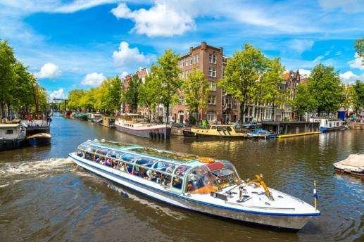
Day 7
Visit Keukenhof Gardens (till 11th May). Visit picturesque Dutch Village of Windmills and Tradition (from 12th May). Explore Amsterdam with Canal Cruise.
Drive to Germany.
Check out and later we relax in our coach as we travel to the charming city of Lisse. Here, we'll have the incredible opportunity to visit the renowned Keukenhof Gardens, open until May 11th. Prepare to be mesmerized by the vast displays of tulips, daffodils, and hyacinths, creating a breathtaking array of colours. From 12th May we proceed to charming Dutch village near Amsterdam known for its iconic windmills, traditional wooden houses, and artisan workshops, offering a glimpse into 18th-century Dutch life and culture. Next we drive to the Dutch capital Amsterdam and embark on a glass-topped boat where you will have the opportunity to explore the rich history of this city. Immerse yourself in the vibrant legacy of the city, characterized by its 1,000 bridges and charming old houses. Afterward, continue your picturesque journey towards your hotel in the Frankfurt area and complete the check-in process.
Amsterdam Canal Cruise
Overnight stay at the hotel in Germany. (Breakfast, Lunch, Dinner)
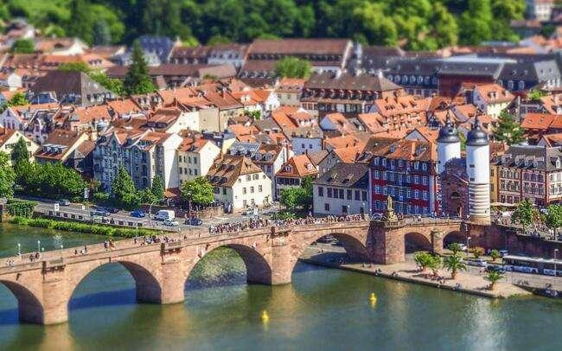
Heidelberg Alstadt
Day 8
Visit the Heidelberg Alstadt and see the Church of the Holy Spirit. Travel to the Heart of the Black Forest, where you'll have the chance to witness the grandeur of the largest waterfall in Switzerland, the Rhine Falls with a thrilling boat ride.
After checking out, relax in your coach as we drive Heidelberg Altstadt (Old Town) which spreads around the Market Square and stretches along the Neckar River. Sat just below Heidelberg Schloss (castle) it hosts old and modern houses in a maze of narrow, cobblestoned streets. During our time in the Alstadt, also see the Church of the Holy Spirit is a landmark of Heidelberg and is as fascinating as a medieval cathedral. Next we proceed to the heart of the Black Forest, renowned for its dense evergreen forests and charming villages. You'll be captivated by the scenic beauty of these quaint villages nestled in the heart of the Black Forest. Additionally, you'll have the unique opportunity to witness a demonstration of how traditional cuckoo clocks are crafted, a true Black Forest specialty.
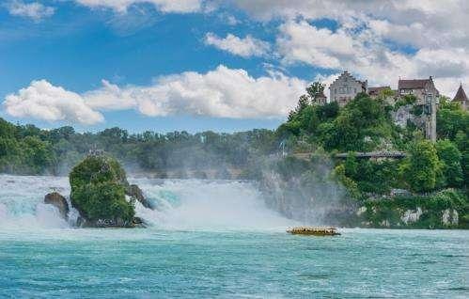
Later relax and take in the picturesque journey en route to Switzerland. Explore the Rhine Falls with a boat ride which offers a thrilling close-up experience of the powerful cascading waters where you can behold the breathtaking Rhine Falls, the largest and most stunning waterfall in Europe. The cascading waters of the Rhine River create a mesmerizing spectacle, drawing visitors to its scenic surroundings and boat excursions for a closer encounter with this natural wonder. Later, we'll continue our drive to your hotel.
Rhine Falls
Overnight stay at the hotel in Central Switzerland. (Breakfast, Lunch, Dinner)

Day 9
Enjoy the tour's crowning jewel: An enchanting alpine adventure to the summit of Europe, the breath taking Jungfraujoch included in your tour cost paired with the picturesque beauty of Interlaken.
Today we proceed to Interlaken - a picturesque Swiss town nestled between two stunning lakes, offering breath taking mountain views and serving as a gateway to numerous alpine adventures.
Later, prepare yourself for an unforgettable and magical alpine journey to Jungfraujoch, also known as "The Top of Europe" — undoubtedly one of the highlights of your tour. Our adventure begins as we head to the Grindelwald Terminal. From there, the state-of-the-art 3S-Bahn Eiger Express whisks you away to the Eigergletscher station in a mere 15 minutes. Here, you'll step onto a cogwheel train that will transport you to the highest railway station in Europe, nestled at an awe-inspiring altitude of 11,333 feet.
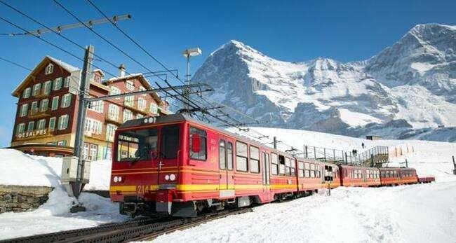
Upon arrival, you'll find yourself in a realm of eternal ice and snow, where natural beauty knows no bounds. Explore the enchanting Ice Palace, where skilled artists craft their masterpieces from ice. Ascend to the Sphinx observatory deck, perched high above, and prepare to be captivated by a panoramic view that stretches across the Aletsch Glacier, the longest glacier in the Alps. This is a journey into a world of unparalleled natural splendour that you will remember for a lifetime.
Cogwheel Train to Jungfrau included
Overnight stay at the hotel in Central Switzerland. (Breakfast, Lunch, Dinner).
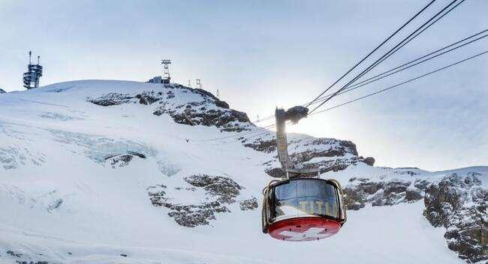
ROTAIR to Mt. Titlis

Day 10
Visit Mt. Titlis- enjoy Cable car rides including the world’s first rotating cable car, the Rotair – to the top of Mt. Titlis at 3,020 metres. A brief orientation tour of Lucerne. Entrance to Switzerland’s ultimate chocolate attraction – The Lindt Home of Chocolate.
Swiss Chocolate Adventure
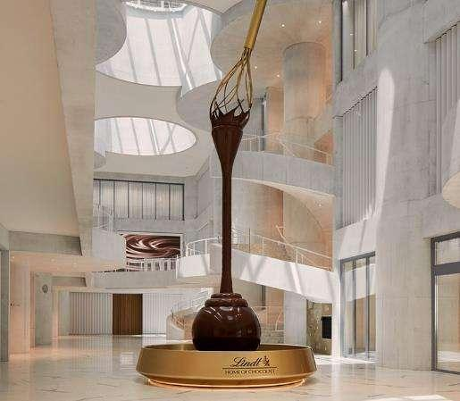
Our journey continues to Lucerne, where you'll be treated to breath taking scenery and a once-in-a-lifetime experience. We'll embark on an exhilarating trip to the summit of Mt. Titlis, reaching an elevation of 3,020 meters by way of various cable cars, including the Rotair, renowned as the world's first revolving cable car. At this lofty vantage point, prepare to be awestruck by a breath taking, unobstructed 360-degree panorama. You'll take in stunning views of the snow-capped peaks, deep crevasses, and pristine white snowfields, adorned with massive ice boulders, visible from every angle. Don't forget to include a visit to the "Cliff Walk," Europe's highest suspension bridge, perched along the cliffs of Mt. Titlis.
Later in the day, we'll proceed for a brief orientation tour of Lucerne, celebrated as one of Switzerland's most enchanting cities. You'll have the opportunity to visit the iconic Lion Monument and admire the charm of the Kapellbrücke, a covered wooden bridge. It's a day filled with cultural exploration and awe-inspiring natural beauty. Following the tour in Lucerne, get ready for an exciting tour through the world of chocolate, and learn everything you ever wanted to know about chocolate with a visit to Lindt.
Lindt Home of Chocolate
Overnight stay at the hotel in Central Switzerland. (Breakfast, Lunch, Dinner)

Day 11
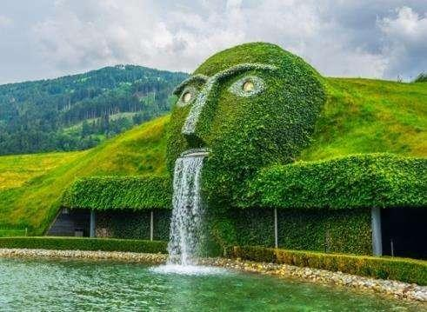
Drive to Vaduz, the capital at the Principality of Liechtenstein with a guided mini train ride. Visit Swarovski Crystal Museum – the dazzling world of crystals. Visit Innsbruck – The Tyrolean capital of picturesque Austria.
Today after breakfast, Relax in your coach as you take a scenic drive to Innsbruck. Enroute arrive in Vaduz, the capital of Liechtenstein, a tiny principality nestled between Switzerland and Austria. It lies entirely within the Alps and covering an area of just sixty-two square miles. Liechtenstein is the sixth smallest independent nation in the world. It follows a policy of neutrality and is one of the few countries in the world that maintains no military. The Vaduz train ride offers a serene and immersive way to appreciate the natural beauty and idyllic surroundings that make Liechtenstein so special.
Swarovski KristallweltenWattens
Next we proceed to Wattens, where you'll have the opportunity to explore the Swarovski World of Crystals and be enchanted by the exquisite crystalline artworks on display.
Following this captivating visit, we'll continue on to Innsbruck, a city of extraordinary beauty. During our orientation tour, you'll have the chance to admire the iconic Golden Roof, known for its fire-gilded copper tiles, which serves as a defining landmark of Innsbruck. Stroll along the charming cobblestone paths of Maria Theresien Strasse, where you can choose to relax at one of the many outdoor cafes. As you do so, you'll be treated to magnificent baroque architecture and the chance to immerse yourself in the rich culture of medieval Europe. With the splendid Alps as a backdrop, the setting is nothing short of a picture-postcard perfect.
Overnight stay at the hotel in Innsbruck / Seefeld. (Breakfast, Lunch, Dinner)
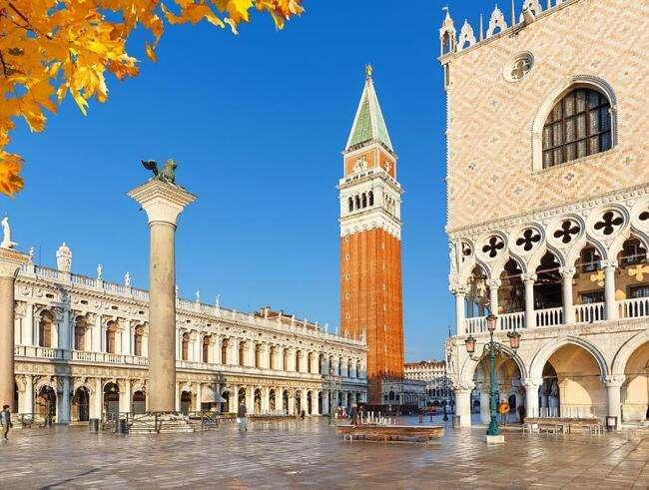
St. Mark’s Square

Day 12
Welcome to Venice, Italy, the captivating floating city. Immerse yourself in the enchanting experience of a gondola ride through its picturesque waterways.
Check out from your hotel and embark on a journey to Venice, Italy, a city adorned with beautiful monuments and famed for its serpentine canals—a place that has inspired poetry and passion throughout the ages.
Upon arrival at the pier in Venice, we'll board a private boat. Our destination is St. Mark's Square, the heart of Venice. Here, you'll have the opportunity to view St. Mark's Basilica, an exquisite example of Byzantine architecture. Witness the renowned Bell Tower and Clock Tower, the latter adorned with the dominant sign of the Zodiac and the current phase of the moon.
As we explore further, you'll catch sight of the iconic Bridge of Sighs, a magnificent structure crafted from white limestone. It spans the Rio di Palazzo, connecting the old prisons with the interrogation rooms at the Doge's Palace.
To truly embrace the enchantment of Venice, we'll treat you to a romantic gondola ride in a flat-bottomed Venetian rowing boat. Glide through the city's canals, surrounded by the stunning backdrop of baroque buildings—an experience that encapsulates the essence of this captivating city. Following our adventures, we'll return to the pier and proceed to check in at your hotel.
Overnight stay at the hotel in Padova/Bologna/Ferrara. (Breakfast, Lunch, Dinner)

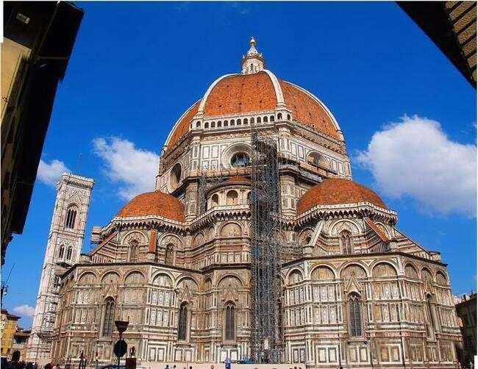
Day 13
Guided city tour of Florence. View the Duomo – Florence most iconic landmark. View the remarkable and famous Leaning Tower of Pisa.
Basilica Di Santa Croce
This morning, after checking out from your hotel, we'll embark on a journey to Florence, often referred to as the cradle of the Renaissance. Accompanied by an English-speaking local guide, you'll immerse yourself in the rich culture of this historic city.
During your exploration, you'll have the opportunity to admire several iconic landmarks, including the Duomo, which stands as the city's most recognizable symbol. Gaze upon the Campanile and the Baptistery, the latter renowned for its Gates of Paradise.
As we continue our journey through Florence, you'll encounter the vibrant Piazza Della Signoria—a veritable open-air museum adorned with Renaissance sculptures. This bustling square is bordered by historic cafes and dominated by the magnificent Palazzo Vecchio. We'll also take in the renowned Ponte Vecchio, a bridge that spans the River Arno.
Following this captivating experience, we'll proceed towards Pisa. Upon arrival, you'll be treated to a view of the Square of Miracles, home to the astounding Leaning Tower of Pisa—a sight that never fails to leave a lasting impression.
Overnight stay at the hotel in Tuscany region. (Breakfast, Lunch, Dinner)
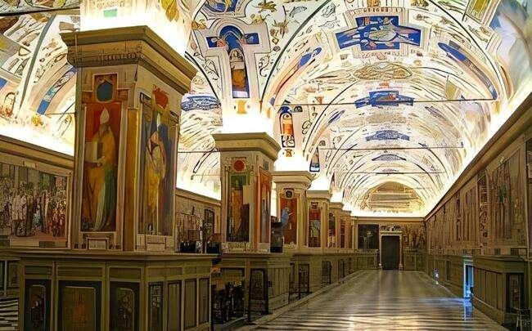
Vatican Museum with Sistine Chapel

Day 14
Trip to the eternal city of Rome. Visit the world’s smallest country – the Vatican City and St. Peter’s Basilica
Today, it's time to check out and make our way to the eternal city of Rome. Prepare for an orientation city tour of Rome. Our stop is the Vatican City, the world's smallest country. (Please note that shorts or sleeveless vests are not allowed in the Vatican.)
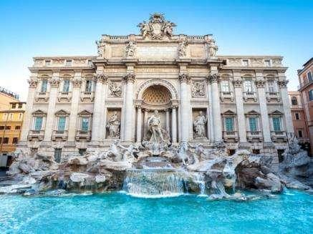
The tour also includes a visit to the famous Sistine Chapel, celebrated for its masterpiece, "The Last Judgement," and recognized as the place where the Pope is elected. The divinely beautiful St. Peter's Basilica will leave you mesmerized with the works of Michelangelo and Bernini.
Our journey continues as we drive to view the magnificent Colosseum, an immense amphitheater that remains impressively well-preserved. Next on our itinerary is a visit to the stunning Trevi Fountain. Legend has it that tossing a coin over your shoulder into the fountain ensures your return to Rome. We'll proceed to view the majestic Victor Emmanuel Monument, explore the Roman Forum, and discover several more remarkable sights that enrich the cultural tapestry of this extraordinary city. Please note that the entry to the Vatican Museums and Sistine Chapel may require standing in queue. The typical waiting time is approximately 1.5 hours, depending on the crowd size. This is pratically because of the Jubilee year in Italy. Incase of non availability for the entracne tickets, then your TM will notify you in advance and instead will take you to the Colosseum with the entrance.)
Trevi Fountain
Overnight stay at the hotel in Rome. (Breakfast, Lunch, Dinner)

Day 15
Fly back home
As your memorable holiday comes to a close, today marks the day to return home. Bid farewell to the wonderful new friends you've made during this tour. It's time to check out and make your way to the airport, carrying with you the pleasant memories of your European journey—a treasure you'll cherish for a lifetime. Safe travels! (Breakfast)

Inclusion: Sightseeing and excursions

UNITED KINGDOM
London
- City tour with a local guide
- Entrance to Madame Tussauds Wax Museum
- Ride the London Eye
- Entrance to Lord’s Cricket Ground with lunch

Highspeed Eurostar Train from London to Paris

FRANCE
Paris
- City tour with a local guide
- Visit to the 3rd level of the Eiffel Tower
- Guided tour of Versailles Palace
- Full day excitement and thrill at Disneyland® Paris
- Enjoy romantic cruise on River Seine
- Paris by Night Tour

BELGIUM
Brussels
- Orientation tour of Brussels
- See the Mannekin Pis Statue
- Entrance to Mini Europe

NETHERLANDS
Amsterdam
- Entrance to Keukenhof (till 11th May)
- Visit traditional Dutch fishing village and windmills (from 12th May)
- Amsterdam Canal Cruise

GERMANY
Heidelberg
- Walk down the Heidelberg Alstadt
- See the Church of the Holy Spirit
Titisee
- Drive to the heart of the Black Forest
- Witness a demonstration of Cuckoo Clocks

SWITZERLAND
Schaffhausen
- See the magnificent Rhine falls with a thrilling boat ride

Interlaken
- Excursion to Jungfraujoch - Top of Europe
- Visit scenic Interlaken
Engelberg
- Witness breath-taking mountain peaks and glaciers at Mt. Titlis
- Ride in the world’s first revolving cable car
- Walk on the Highest suspension bridge in Europe - Titlis Cliff Walk
Lucerne
- Orientation tour of Lucerne
Zurich
- Entrance to Lindt Home of Chocolate

LIECHTENSTEIN
Vaduz
- Guided tour of Vaduz with a mini train ride

AUSTRIA
Innsbruck
- See the Maria Theresien Strasse and the Golden Roof
Wattens
- Visit the Swarovski Crystal Museum and shop

ITALY
Venice
- St. Mark’s square by Private boat
- Enjoy a classic Venetian Gondola ride
Florence
- Guided walking city tour with a local English-speaking guide.
Pisa
- Visit Square of Miracles
- Photo-stop at the Leaning Tower
Rome
- Rome Orientation tour
- Visit to Trevi Fountain

VATICAN CITY
Vatican City
- Visit the Vatican Museum and Sistine Chapel – see sculptures and masterpieces of Renaissance art
- Visit the magnificent St. Peter’s Basilica

Accommodation:
- 02 nights accommodation in Sheraton Skyline / Mercure LHR / Holiday Inn or similar Hotel in London
- 03 nights accommodation in B&B / Millennium CDG / Hilton CDG or similar hotel in Paris
- 01 night accommodation in Novotel / NH / Fletcher or similar hotel in Netherland
- 01 night accommodation in Mercure / Rilano / NH or similar hotel Germany
- 03 nights accommodation in Radisson / Ramada / Movenpick or similar hotel in Central Switzerland
- 01 night accommodation in Alpenkoning / Alphotel or similar hotel Innsbruck / Seefeld
- 01 night accommodation in Four Points by Sheraton / Unaway / Capital or similar hotel in Padova / Rovigo
- 01 night accommodation in B&B / Park / A Point or similar hotel in Tuscany
- 01 night accommodation in SHG / Hampton by Hilton / Marriott or similar hotel in Rome
Meals
- Daily Continental Buffet Breakfast.
- 13 Indian Jain/Vegetarian/Non-Vegetarian Lunches.
- 14 Indian Jain/Vegetarian/Non-Vegetarian Dinners.
- Daily Mineral Water Bottle (500ml)
(Packed lunch will be served on the day you travel from London to Paris and on the day you visit Disneyland Paris)

Driver Tips:
- Tips to coach drivers per person, per day 5 EURO will be charge and added in the final payments a for the duration of the tour.

Payment Policy:
100, 000.00 INR per person at the time of the booking
IF we booked your air tickets, Full payment of the cost within 1 week of the ticket booking
75 days prior to tour departure 75000.00 INR per person.
60 Days prior to tour departure full payment with tips 5 euro per person per dayshould be
paid and cleared from our bank.
IF two travelers sharing room in tour and one of them drop out/ cancelled the tour,
remaining traveler charge as a single traveler.

Cancellation Policy with full airfare cost:
90 days prior to tour departure 40,000.00 INR per person at the time of cancellation
IF we booked your air tickets, Full payment.
75 days prior to tour departure 150000.00INR per person.
60 – 44 Days prior to tour departure full payment.

Important Notes:
GST 5%is applicable on total cost
TCS -5to 20% on total tour cost as per Indian govt, rules
Exchange rate for Euro= 96 INR will be charge at rate of the final payment time.
All Hotel Room category is standard room (Basic category) Hotel is not
In city centre or downtown.
We are not giving refund of any sightseeing closed due to maintenance
or weather, political, riots and /or other situations not under our control.
Vehicle Policy:
During Sight Seeing Driver Will Try His Best to Park as Much Closer He
Can, From There Guest Has to Make His Way by Walk or They Have To
make their own transfer If Require any.In caseofcoachbreakdown
TRAVELGROCERYDMC.PVT.LTD and tour providerswilldoTheir
best effort to fix the problem as soon as possible. But make sure there
will be no refund for inconvenience cause. Request to all guest please
don’t leave Any Unattended Item in vehicle while leaving the vehicle.
What your tour price does not include:
- The cost of the Airfare, Passport, POE charges, Visa charges, Overseas Travel Insurance, etc.
- Any expenses of personal nature such as Porterage, Laundry, and Alcohol, Food or Drink not in the regular menus provided by us, mini bar and telephone calls
- Any extra meals not included in the itinerary. Meals are pre - set and a choice of menu is not available, No refund of any unused meals, services, sightseeing, etc.
- Cost of excursions, city sightseeing, entrance fees and local guides availed of by the passengers, other than that mentioned in ‘What your tour price includes’
- GST, TCS and other taxes as applicable
- Anything which is not specified in the Itinerary
- Any item and services not mentioned in Inclusions.
- Tips to coach drivers per person, per day 5 EURO will be charge and added in the final payments a for the duration of the tour.

Instruction for Arrival & Departure Coach Transfers:
London (Heathrow Airport) ArrivalHALL Transfer: Flight landing time should be between 08 AM – 1300hrs.
ROME Departure Transfer: The coach will drop at Airport by 1100 AM.

IMP Notes for Transfers:
- Please advise your client that there may be waiting up to 02 Hours (Post reaching in arrival hall) for arrival transfers.
- If flight timings are before /after the suggested timing, client has to arrange his private transfers on direct payment basis. We will not reimburse any cost for private transfers.

NOTES:
- A person below 12 years of age on the entire tour will be considered a child
- As a 3rd person in a triple room, most hotels use rollaway beds and room size may be the same as the double room
- Tours will operate subject to all Government regulations
- All Local taxes, entrances and services are calculated as on 1st October 2021, any increase in local taxes, entry tickets and other services has to be borne and paid by the traveller/agent.
- All transfers and extensive sightseeing with entrance fees (as specified in the itinerary) will be done in an air-conditioned coach
- On reaching Eiffel Tower, if there is a very long queue, we will be taking you to the Montparnasse tower.
- It is suggested to carry One check in bag and one hand bag per person only, due to limited boot space in the coach
- Services of our tour manager or local representatives, while on tour
- On some occasions, you may have to join another group in case your group does not have adequate members
- A local representative or your coach driver may only be there to assist you during your initial part of the tour
- Land surcharges applicable on certain departure dates which will be notified
- If certain sightseeing/excursions are closed, then alternate sight- seeing will be arranged.
- Kindly note that on certain departure dates the tour routing could change. In some tours, there is also a possibility that the tour could operate in reverse itinerary. However, you will not miss any sightseeing or excursions that are mentioned in the itinerary unless its closed due to a holiday. Your Tour Manager will notify you the same
- In case of inordinate delays and strict driving laws, packed dinner may be provided on that day
- Please check with your Sales representative for final details
- In case of any increase in any taxes in Europe, there would be a change in price which will be justified
- We reserve the right to claim from the passengers, any additional expenses incurred due to delay or changes in the schedule of trains, flights, coach, cruise or other services
- We reserve the right to change any itinerary for operational reasons and reasons beyond the control of us due to Force Majeure related to weather conditions, strike, etc. Force Majeure related to weather conditions, strike, etc.
- We shall not accept any liability or responsibility for any damages, loss, injury, accident, death, delay, breakdown or irregularity, which may occur during the tour, due to weather conditions, strikes, war, quarantine and or any other cause whatsoever and all such loss or expenses must be borne by the passenger
- Tours are operated subject to Reserve Bank of India / Government of India regulations
- Tour cost is payable in EURO out of your BTQ entitlement of the passengers

DirectJoiningGuestHavetoArrangeHotelTransferforCheckinandcheckout
dayby themselves. operation of a Group Tour Is a Subject to Minimum Participation of 25 Paying Adult Passenger. Any Increase in Visa Fee /Airfare / Fuel Price / Change in government Regulations Taxes Etc.will affect your tour Cost.
Tour itinerary will be Strictly Follow as Per Timing. In UnavoidableSituationour
tourmanagerCanMakeChangeswithThe ConcernofHead Office.TourManagerIsNotAuthorizetoMakeChangesinItinerary asPerGuestConvenience.InCaseof anyDeportationDuetoImmigrationand CustomClearance TRAVEL GROCERY DMC PVTLTD and tour providers will Not Be Responsible. There Will Be No Refund for Tour Package. Optional Sightseeing have tobePre-Bookwithan additionalCost.
ThereIsNo Refundforany unutilizedServices.
ItineraryCostIsperpersononTwinSharingbasis.It IncludeonlythoseactivitiesWhicharelistedin theSame.
ItinerarycostdoesnotInclude anyPersonalNatureExpenses.Such as tips, Misc.Expenses,Laundry,Liquor,Porterage. Medical expenses, travel insurance Etc.Internationaltourguestmusthaveto reachAirportbefore3Hrs.ofdepartureTime.
ForNRI–PassengersStayinginIndiafor MoreThan180dayswillhavetotakePolice ClearanceCertificatefromCommissioner ofPoliceforWhichTRAVELGROCERYDMC.PVT.LTD and tour providerswillnotbeResponsible.
PassengersareRequestedtoSubmitXeroxCopyofPassport alongwithpageShowing arrivalstampinIndia.

