TravelExclusive Europe
12 Nights / 13 Days
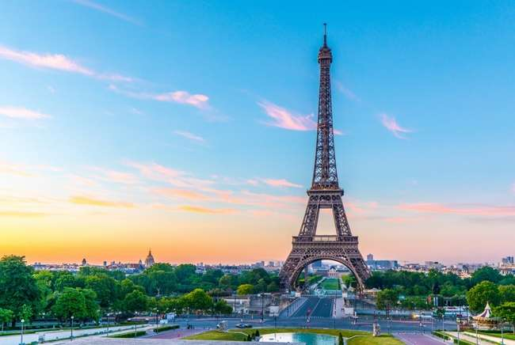

Highlights
- Value-for-Money holiday which you will cherish for a lifetime
- Visit6countries in 13 days: United Kingdom, France, Switzerland, Austria, Italy & Vatican City
- All Important attractions and sightseeing included. Madame Tussauds, London Eye, Lord’s Cricket Ground, Eurostar train from London to Paris, Guided tour of Versailles, Eiffel Tower 3rd level, Full day at Disneyland® Paris, River Seine Cruise,Excursion to Jungfrau included, Entrance to Mt. Titlis, Swarovski Crystal Museum, Visit to St. Mark’s Square with Gondola Ride, Photo stop at Leaning Tower of Pisa and entrance to St. Peter’s Basilica.
- Guided tour in London, Paris &Florence
- Services of a Professional & Knowledgeable Tour Manager accompanying you throughout the tour
- Accommodation in superior 4-star hotels
- Daily Continental buffet breakfast.
- Delicious unlimited variety of Jain, veg and nonveg Indian cuisine included as per itinerary.
- Daily mineral water bottle (500ml)

Day 1
Arrive into London, the capital of England and the United Kingdom.
Greetings! Today marks the commencement of our journey as we embark on a flight to a captivating city renowned for its vibrant culture, cosmopolitan atmosphere, and intriguing history – London, the capital of England. Upon arrival, you will be warmly welcomed by our amiable and knowledgeable Tour Manager, who will guide you to your hotel and facilitate a smooth check-in process. Take some time to unwind and enjoy the comforts of your accommodation.
Overnight in London. (Dinner)
Tower Bridge
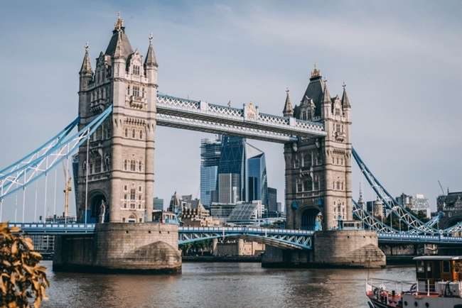

Day 2
Guided city tour of London with Changing of Guards. Visit the legendary Lord’s Cricket Ground. Ride the London Eye.
Today we proceed to explore the city of London with our expert local guide. You will see important landmarks like the Big Ben, Houses of Parliament, Westminster Abbey, Trafalgar Square, Piccadilly Circus, Tower Bridge, River Thames, Hyde Park and many more. Witness the Changing of the Guards at Buckingham Palace (subject to operation). Next we proceed to visit one of the iconic cricketing venues in London – the Lord’s Cricket Ground. In Lord’s you will have an opportunity to go behind the scenes at the ‘Home of Cricket’, and to experience some of the most inspiring views in sport. See the iconic parts of the ground including the Grade II*-listed Victorian Pavilion, the world-famous Long Room, the Players’ Dressing Rooms, and the MCC Museum, home of the Ashes Urn – cricket’s best-known artefact. Complete your visit with a delightful lunch, soaking in the atmosphere of this storied ground—a must for any cricket enthusiast! Later we visit London eye, one of the many iconic highlights of the city. Enjoy scenic views of the city while you ride the London eye. It is one of the most popular tourist attractions in the United Kingdom, standing at 135 meters tall overlooking the river Thames and the beautiful city of London.
Overnight in London. (Breakfast, Lunch, Dinner)

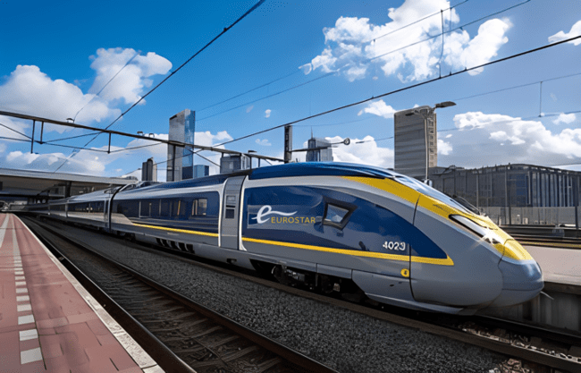
Day 3
Arrive into Paris - the City of Romance, Lights and Glamour.
Check out of your hotel and proceed to travel by high speed train from London to Paris. Eurostar is a high-speed train service connecting London with Paris through the Channel Tunnel. Offering a swift and efficient journey, it provides a seamless travel experience between these iconic European cities. After disembarking proceed to the fashionable and elegant city Paris, known for its haute couture, renowned museums, breathtaking beautiful monuments and sensational cabarets. En route enjoy the English and French Countryside.
Eurostar Train – London to Paris

Overnight at the hotel in Paris. (Breakfast, Packed Lunch, Dinner)

Day 4
Guided city tour of Paris. Visit to Eiffel tower 3rd (Top) Level. Visit the Palace of Versailles, a testament to the pinnacle of French 17th-century artistry and achievement. Enjoy a romantic cruise on the River Seine.
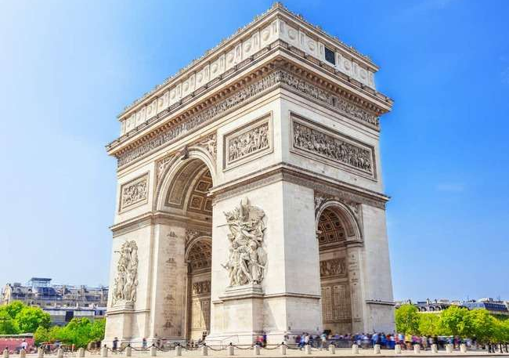
Today proceed for a guided city tour of Paris. Marvel at the finest Parisian tourist attractions, Place Vendôme, Place de l’Opéra Garnier, Musée d’Orsay, Place de la Concorde, Champs Elysées, one of the most recognised fashionable avenues in the world, Arc de Triomphe, Alexander Bridge, Les Invalides and several others. Next visit the iconic Eiffel Tower – 3rd Level, and get a stunning view of the city from the top. With its famous tapering cast iron tip, the Eiffel Tower is not just the symbol of Paris but of all of France.
Arc De Triomphe
Arc De Triomphe
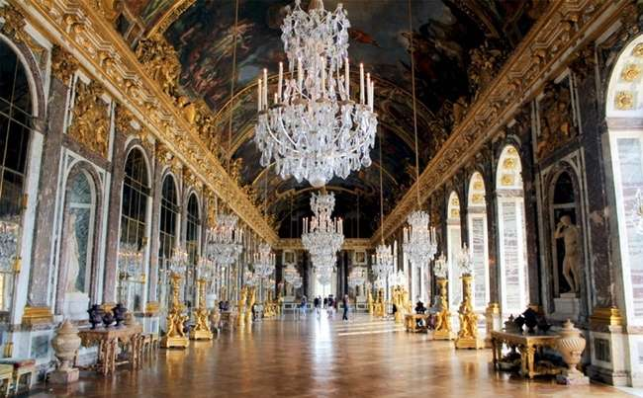
Our adventure continues with a visit to the Palace of Versailles, an internationally acclaimed masterpiece located in Versailles, approximately 12 miles (19 km) west of Paris, France. This magnificent palace is the property of the French Republic and has been under the stewardship of the Public Establishment of the Palace, Museum, and National Estate of Versailles, overseen by the French Ministry of Culture since 1995. Later take a romantic cruise down the river Seine, one of the world’s most scenic cruise, flanked by exquisite monuments like Notre Dame, Eiffel Tower, Louvre, Orsay Museum and many more. Gliding under one bridge to one another with a view of the finest monuments in the heart of bustling Paris.
Hall of Mirrors – Versailles Palace
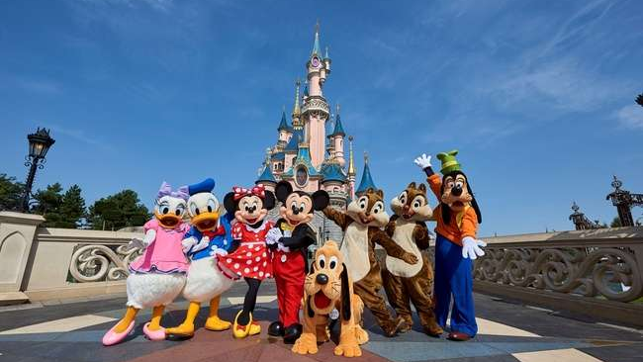
(IMP NOTE - Please note that access to the Eiffel Tower's 3rd level is contingent on its operational status and the entry involves standing in queue with average waiting time of approx. 1 to 2 hours. If it happens to be closed during our visit, we will make the necessary adjustments and proceed to explore the 2nd level instead. Your experience will still be enriched by the fantastic views and the charm of the Eiffel Tower.)

Disneyland® Paris

Day 5
Enjoy your fun filled day at Disneyland® Paris choice of Disney® Park or Walt Disney Studios® Park.
Get ready for a day full of excitement at Disneyland Paris- a popular amusement park. Enjoy different kind of thrill rides and studio movies with your loved ones. You may choose between Disney Park, where fairy tales take flight across five incredible lands filled with classic attractions, shows and street parades with Disney Characters OR you may visit the Walt Disney Studios Park Studios and be astounded by the outstanding stunt shows, watch a film being made and see real-life sets used for creating blockbuster movies.
Overnight at the hotel in Paris.(Breakfast, Packed Lunch, Dinner)

Day 6
Orientation tour of Geneva.
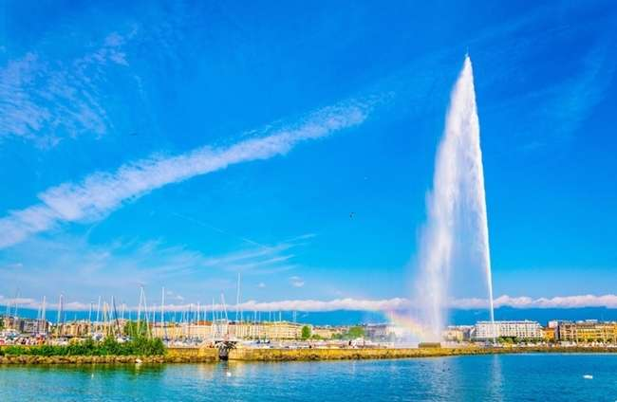
Check out from your hotel and proceed to Switzerland, a mountainous Central European country, home to numerous lakes, villages and the high peaks of the Alps. On arrival proceed for orientation tour of Geneva. See The Jet d'Eau, a large fountain in Geneva, Switzerland and is one of the city's most famous landmarks, UN Buildings - The United Nations Office and the Flower Clock, located just in front of the famous Lake Geneva. Later proceed to your hotel and check-in and relax in the comforts of your hotel.
Jet d’Eau
Overnight at the hotel in Geneva. (Breakfast, Packed Lunch, Dinner)

Day 7
Enjoy a magical alpine excursion to the top of Europe - the amazing Jungfraujoch which is included in your tour and scenic Interlaken.
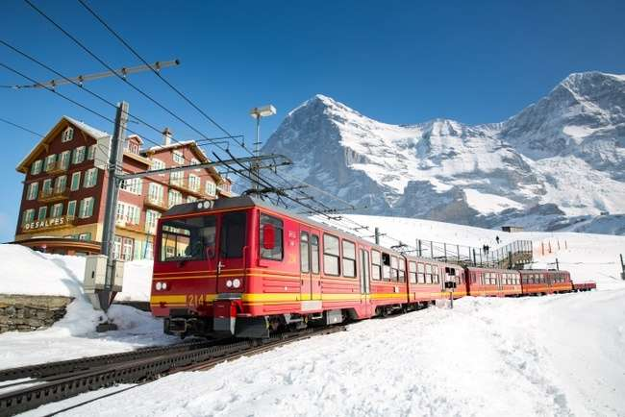
Get set for a memorable magical alpine excursion to Jungfraujoch – The Top of Europe, a high–point of your tour. First proceed to Grindelwald Terminal. The new 3S-Bahn Eiger Express takes you from the Grindelwald Terminal to the Eigergletscher station in just 15 minutes. There you board a cogwheel train to reach the highest railway station in Europe at 11,333 feet – a world of eternal ice and snow. Visit the Ice Palace where artistes create their work of art in ice. Visit the Sphinx observatory deck to experience a breath-taking panoramic view of the longest glacier in the Alps - Aletsch Glacier.
Cogwheel Train to Jungfraujoch included
Overnight at the hotel in Central Switzerland. (Breakfast, Lunch, Dinner)

Day 8
Visit Mt. Titlis- enjoy Cable car rides including the world’s firstrotating cable car, the Rotair – to the top of Mt. Titlis at 3,020 metres. Enjoy a scenic cruise on Lake Lucerne.
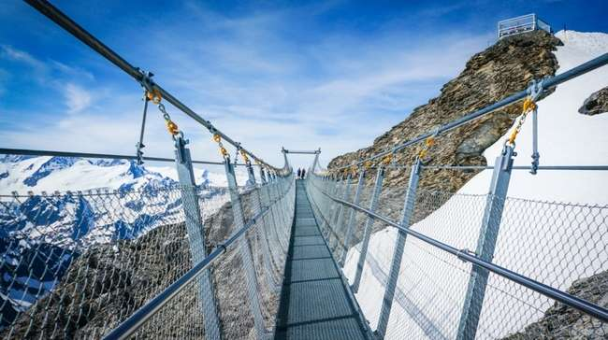
Today enjoy amazing scenery, a once in a lifetime experience with an exhilarating tip to the top of Mt Titlis at 3020 metres on various cable cars including Rotair, the world’s first revolving cable car. Get a breath taking unrestricted 360 degrees stunning view of the dazzling snow caped peak, deep crevasses and pristine white snow fields, dotted with massive ice boulders from every angle. Do not forget to visit the “Cliff Walk” the highest suspension bridge in Europe along the cliff of Mt.Titlis. Later proceed on an orientation tour of Lucerne one of most beautiful cities in Switzerland. Visit the Lion Monument, Kapell Brucke with some free time to shop for famous Swiss watches, knives and chocolates. Later enjoy a scenic and relaxing cruise on Lake Lucerne.
Mt. Titlis Cliff Walk
Mt. Titlis – Rotair
Overnight at the hotel in Central Switzerland. (Breakfast, Lunch, Dinner)

Day 9
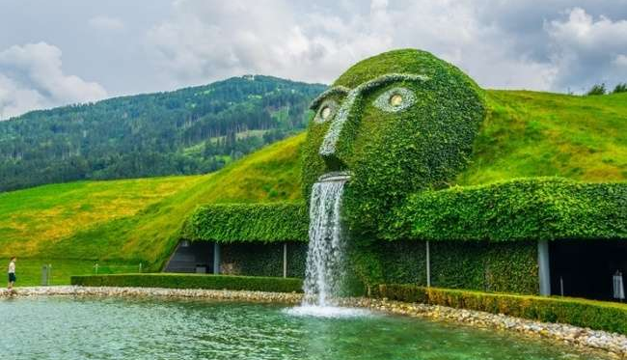
Visit the magnificent Rhine Falls.Visit Swarovski Crystal Museum – the dazzling world of crystals. Visit Innsbruck – The Tyrolean capital of picturesque Austria.
Today after breakfast, sit back and enjoy the scenic drive towards Schaffhausen, where you see the magnificent Rhine Falls – Europe’s biggest and most spectacular falls. Next we proceed to Wattens, where you'll have the opportunity to explore the Swarovski World of Crystals and be enchanted by the exquisite crystalline artworks on display.
Following this captivating visit, we'll continue on to Innsbruck, a city of extraordinary beauty. During our orientation tour, you'll have the chance to admire the iconic Golden Roof, known for its fire-gilded copper tiles, which serves as a defining landmark of Innsbruck. Stroll along the charming cobblestone paths of Maria Theresien Strasse, where you can choose to relax at one of the many outdoor cafes. As you do so, you'll be treated to magnificent baroque architecture and the chance to immerse yourself in the rich culture of medieval Europe. With the splendid Alps as a backdrop, the setting is nothing short of a picture-postcard perfect.
Swarovski Crystal Museum
Overnight in Innsbruck / Seefeld. (Breakfast, Lunch, Dinner)

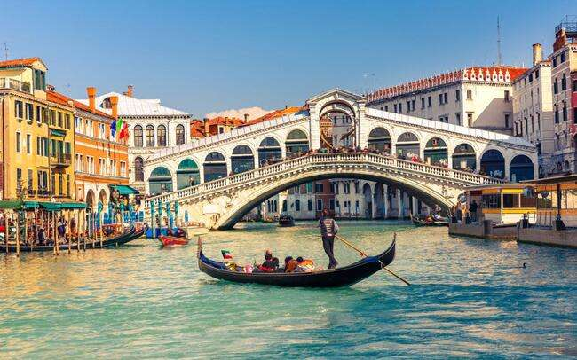
Gondola Ride

Day 10
Welcome to Venice - the floating city of Italy. Enjoy Gondola ride.
Check out of your hotel and proceed towards Venice – Italy. City of Beautiful Monuments, Serpentine Canals, city that inspired poetry and passion through the ages. Arrive at the pier in Venice, where we board a private boat to arrive at St. Mark’s Square – the main square of Venice. View St Mark’s Basilica - one of the best examples of Byzantine architecture, Witness the famed Bell Tower and Clock Tower with the dominant sign of the Zodiac and current phase of the moon. See the Bridge of Sighs, made of white limestone, that passes over the Rio di Palazzo, connecting the old prisons with interrogations rooms at the Doge’s Palace. Treasure a romantic Gondola ride in a flat-bottomed Venetian rowing boat, amidst the stunning backdrop of baroque buildings. This truly is the best way to enjoy this enchanting city. We return to the pier and later check in to your hotel.
Overnight in Padova/Bologna. (Breakfast, Lunch, Dinner)

Day 11
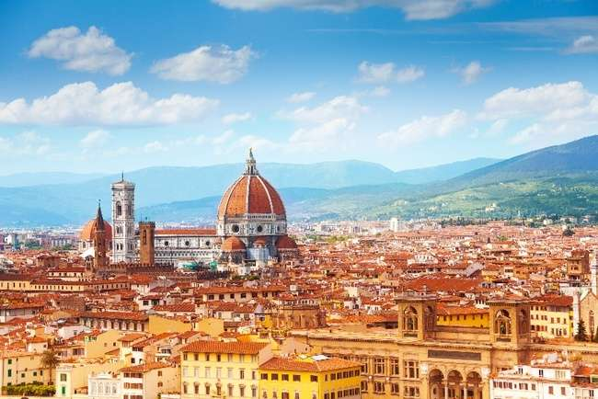
Guided walking city tour of Florence. View the remarkable and famous Leaning Tower of Pisa.
This morning check out and drive to Florence – the cradle of the Renaissance. Along with your English-speaking local guide, walk and absorb into the culture of the historic city. View the Duomo – the city’s most iconic landmark, the Campanile and the Baptistery with its Gates to Paradise. Also see the Piazza Della Signoria – an open-air museum crammed with Renaissance sculptures, edged by historic cafes and presided over by the magnificent Palazzo Vecchio and the famed Ponte Vecchio (bridge) across the River Arno. Later proceed towards Pisa. On arrival see the Square of Miracles with the stupendous Leaning Tower of Pisa.
Florence Duomo
Overnight in Tuscany region. (Breakfast, Lunch, Dinner)

Day 12
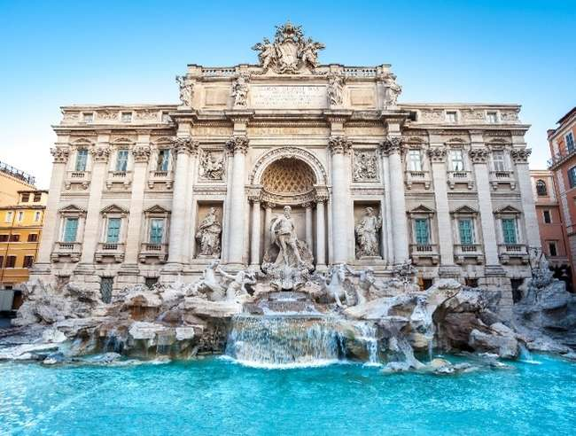
All roads lead to Rome – the eternal city. Visit the world’s smallest country – the Vatican City and see the St. Peter’s Basilica.
Today, we drive to the eternal city of Rome. Our first destination is the Vatican City, the world's smallest independent country. Here, you'll have the opportunity to explore the exquisitely beautiful St. Peter's Basilica, where you can marvel at the magnificent works of art created by masters such as Michelangelo and Bernini.
Trevi Fountain
Our exploration of Rome continues to see the awe-inspiring Colosseum, an immense amphitheater that has endured the passage of centuries, retaining its grandeur and historical significance.
Our next stop on the itinerary is the enchanting Trevi Fountain. According to legend, tossing a coin over your shoulder into the fountain guarantees your return to Rome, making it a cherished tradition among visitors. Check in to your hotel.
Overnight in Rome. (Breakfast, Lunch, Dinner)

Day 13
Fly back home
Your memorable holiday ends, today it’s time to fly back home. Say goodbye to the wonderful new friends you have made on the tour. Check out and depart for the Airport with pleasant memories of your European trip which you will cherish for a lifetime.
(Breakfast)

Inclusion: Sightseeing and excursions

London
- City tour with a local guide
- Entrance to Madame Tussauds Wax Museum
- Ride the London Eye
- Lord’s Cricket Ground

Highspeed Eurostar Train from London to Paris

FRANCE
Paris
- City tour with a local guide
- Visit to the 3rd level of the Eiffel Tower
- Full day excitement and thrill at Disneyland® Paris
- Romantic cruise on River Seine
- Guided tour of Versailles

SWITZERLAND
Geneva
- Orientation tour of Geneva
- See the Jet d’Eau
Interlaken
- Excursion to Jungfraujoch - Top of Europe
- Visit scenic Interlaken
Engelberg
- Witness breath-taking mountain peaks and glaciers at Mt. Titlis
- Ride in the world’s first revolving cable car
- Walk on the Highest suspension bridge in Europe - Titlis Cliff Walk
Lucerne
- Orientation tour of Lucerne
- Lake Lucerne Cruise
Schaffhausen
- View the magnificent Rhine Falls

AUSTRIA
Innsbruck
- See the Maria Theresien Strasse and the Golden Roof
Wattens
- Visit the Swarovski Crystal Museum and shop

ITALY
Venice:
- St. Mark’s square by Private boat
- Enjoy a classic Venetian Gondola ride
Florence:
- Guided walking city tour with a local English-speaking guide
Pisa
- Visit Square of Miracles
- Photo-stop at the Leaning Tower
Rome:
- Visit to Trevi Fountain

VATICAN CITY
Vatican City
- Visit the magnificent St. Peter’s Basilica

Accommodation:
- 02 nights accommodation in Sheraton Skyline / Mercure LHR / Holiday Inn or similar Hotel in London
- 03 nights accommodation in B&B / Millennium CDG / Hilton CDG or similar hotel in Paris
- 01 night accommodation in a 4 star hotel in Geneva
- 02 nights accommodation in Radisson / Ramada / Movenpick or similar hotel in Central Switzerland
- 01 night accommodation in Alpenkoning / Alphotel or similar hotel Innsbruck / Seefeld
- 01 night accommodation in Four Points by Sheraton / Unaway / Capital or similar hotel in Padova / Rovigo
- 01 night accommodation in B&B / Park / A Point or similar hotel in Tuscany
- 01 night accommodation in SHG / Hampton by Hilton / Marriott or similar hotel in Rome

Meals
- Daily Continental Buffet Breakfast.
- 11 Indian Jain/Vegetarian/Non-Vegetarian Lunches.
- 12 Indian Jain/Vegetarian/Non-Vegetarian Dinners.
- Daily Mineral Water Bottle (500ml)
(Packed lunch will be served on the day of Euro Star Train, Disneyland Paris drives to Geneva)
What your tour price does not include:
- The cost of the Airfare, Passport, POE charges, Visa charges, Overseas Travel Insurance, etc.
- Any expenses of personal nature such as Porterage, Laundry, and Alcohol, Food or Drink not in the regular menus provided by us, mini bar and telephone calls
- Any extra meals not included in the itinerary. Meals are pre - set and a choice of menu is not available
- Cost of excursions, city sightseeing, entrance fees and local guides availed of by the passengers, other than that mentioned in ‘What your tour price includes’
- GST, TCS and other taxes as applicable
- Anything which is not specified in the Itinerary

Instruction for Arrival & Departure Coach Transfers:
London (LHR Airport) Arrival Transfer: Flight landing time should be between
08 AM – 1300 HRS.
Rome (FCO Airport) Departure Transfer: The coach will drop at FCO Airport by 1100 AM.

IMP Notes for Transfers:
- Please advise your client that there may be waiting up to 02 Hours (Post reaching in arrival hall) for arrival transfers.
- If flight timings are before / after the suggested timing, client has to arrange his private transfers on direct payment basis. We will not reimburse any cost for private transfers.

Driver Tips:
- Tips to coach drivers per person, per day 5 EURO will be charge and added in the final payments a for the duration of the tour.
Payment Policy:
100, 000.00 INR per person at the time of the booking
IF we booked your air tickets, Full payment of the cost within 1 week of the ticket booking
75 days prior to tour departure 75000.00 INR per person.
60 Days prior to tour departure full payment with tips 5 euro per person per dayshould be
paid and cleared from our bank.
IF two travelers sharing room in tour and one of them drop out/ cancelled the tour,
remaining traveler charge as a single traveler.
Cancellation Policy with full airfare cost:
90 days prior to tour departure 40,000.00 INR per person at the time of cancellation
IF we booked your air tickets, Full payment.
75 days prior to tour departure 150000.00INR per person.
60 – 44 Days prior to tour departure full payment.
Important Notes:
GST 5%is applicable on total cost
TCS -5to 20% on total tour cost as per Indian govt, rules
Exchange rate for Euro= 96 INR will be charge at rate of the final payment time.
All Hotel Room category is standard room (Basic category) Hotel is not
In city centre or downtown.
We are not giving refund of any sightseeing closed due to maintenance
or weather, political, riots and /or other situations not under our control.
Vehicle Policy:
During Sight Seeing driver will try his best to park as much closer He
can, from there guest Has to make His way by walk or they have To
make their own transfer If require any.In caseofcoachbreakdown
TRAVELGROCERYDMC.PVT.LTD and tour providerswilldoTheir
best effort to fix the problem as soon as possible. But make sure there
will be no refund for inconvenience cause. Request to all guest please
don’t leave Any unattended Item in vehicle while leaving the vehicle.
What your tour price does not include:
- The cost of the Airfare, Passport, POE charges, Visa charges, Overseas Travel Insurance, etc.
- Any expenses of personal nature such as Porterage, Laundry, and Alcohol, Food or Drink not in the regular menus provided by us, mini bar and telephone calls
- Any extra meals not included in the itinerary. Meals are pre - set and a choice of menu is not available, No refund of any unused meals, services, sightseeing, etc.
- Cost of excursions, city sightseeing, entrance fees and local guides availed of by the passengers, other than that mentioned in ‘What your tour price includes’
- GST, TCS and other taxes as applicable
- Anything which is not specified in the Itinerary
- Any item and services not mentioned in Inclusions.
- Tips to coach drivers per person, per day 5 EURO will be charge and added in the final payments a for the duration of the tour.
- Please advise your client that there may be waiting up to 02 Hours (Post reaching in arrival hall) for arrival transfers.
- If flight timings are before /after the suggested timing, client has to arrange his private transfers on direct payment basis. We will not reimburse any cost for private transfers.

NOTES:
- A person below 12 years of age on the entire tour will be considered a child
- As a 3rd person in a triple room, most hotels use rollaway beds and room size may be the same as the double room
- Tours will operate subject to all Government regulations
- All Local taxes, entrances and services are calculated as on 1st October 2021, any increase in local taxes, entry tickets and other services has to be borne and paid by the traveller/agent.
- All transfers and extensive sightseeing with entrance fees (as specified in the itinerary) will be done in an air-conditioned coach
- On reaching Eiffel Tower, if there is a very long queue, we will be taking you to the Montparnasse tower.
- It is suggested to carry One check in bag and one hand bag per person only, due to limited boot space in the coach
- Services of our tour manager or local representatives, while on tour
- On some occasions, you may have to join another group in case your group does not have adequate members
- A local representative or your coach driver may only be there to assist you during your initial part of the tour
- Land surcharges applicable on certain departure dates which will be notified
- If certain sightseeing/excursions are closed, then alternate sight- seeing will be arranged.
- Kindly note that on certain departure dates the tour routing could change. In some tours, there is also a possibility that the tour could operate in reverse itinerary. However, you will not miss any sightseeing or excursions that are mentioned in the itinerary unless its closed due to a holiday. Your Tour Manager will notify you the same
- In case of inordinate delays and strict driving laws, packed dinner may be provided on that day
- Please check with your Sales representative for final details
- In case of any increase in any taxes in Europe, there would be a change in price which will be justified
- We reserve the right to claim from the passengers, any additional expenses incurred due to delay or changes in the schedule of trains, flights, coach, cruise or other services
- We reserve the right to change any itinerary for operational reasons and reasons beyond the control of us due to Force Majeure related to weather conditions, strike, etc. Force Majeure related to weather conditions, strike, etc.
- We shall not accept any liability or responsibility for any damages, loss, injury, accident, death, delay, breakdown or irregularity, which may occur during the tour, due to weather conditions, strikes, war, quarantine and or any other cause whatsoever and all such loss or expenses must be borne by the passenger
- Tours are operated subject to Reserve Bank of India / Government of India regulations
- Tour cost is payable in EURO out of your BTQ entitlement of the passengers

DirectJoiningGuestHavetoarrangehoteltransferforcheckinandcheckout
dayby themselves. operation of a group Tour is a Subject to minimum participation of 25paying adult Passenger. Any increase in visa fee /airfare /fuel price /change in government Regulations taxes Etc. will affect your tour cost.
Tour itinerary will be strictly followed as Per timing. In unavoidableSituationour
tourmanagercanmakechangeswiththe concernofHead Office.
TourmanagerIsnotauthorizingtomakechangesinItinerary asPerguestconvenience.Incaseof anydeportationduetoImmigrationand CustomClearance.TRAVEL GROCERY DMC PVTLTD and tour providers will not be responsible. There will be no refund for tour package. Optional Sightseeing have tobePre-bookwithan additionalCost.

ThereIsNo Refundforany unutilizedServices.
ItinerarycostIsperpersonontwinSharingbasis.It Includeonlythoseactivitieswhicharelistedin thesame.

ItinerarycostdoesnotInclude anyPersonalNatureExpenses.Such as tips, Misc.Expenses,Laundry,Liquor,Porterage, Medical expenses, travel insurance Etc.Internationaltourguestmusthaveto reachairportbefore3Hrs.ofdeparturetime.

ForNRI–PassengersstayinginIndiafor moreThan180dayswillhavetotakePolice ClearanceCertificatefromCommissioner ofPoliceforwhichTRAVELGROCERYDMC.PVT.LTD and tour providerswillnotberesponsible.

PassengersarerequestedtosubmitXeroxcopyofpassport alongwithpageShowing arrivalstampinIndia.

